

**Training Report**

**Raspberry Pi & IOT**

**Submitted to:**

**Er. Rohit Khosla Submitted by:**

**(Director) Kashish Jangid**

**Date: Jul 3,2019**

Table of Contents

Raspberry Pi 1

Introduction 1

Raspberry Pi Models 2

1. Raspberry Pi B 2

2. Raspberry Pi Model A: 3

3. Raspberry Pi Model A+: 3

4. Raspberry Pi Model B+: 4

5. Raspberry Pi Zero: 5

6. Raspberry Pi 2 Model B+: 6

7. Raspberry Pi 3 Model B: 7

8. Raspberry Pi 3 Model B+: 7

Comparison: 8

Installing OS on Raspberry Pi: 10

1. Downloading NOOBS 11

2. Formatting the SD Card 11

3. Extracting NOOBS from the zip archive 11

4. Copying the files 12

5. Booting from NOOBS 12

Configuring Raspberry Pi: 13

Using Command Line: 13

Graphical Method: 14

Raspberry Pi Camera Using Motion 15

Components Required: 15

Setup Pi and Camera: 15

WINSCP: 19

Installation: 19

Connecting: 21

Remote Access 23

1. Set up wireless connectivity 23

2. Enable SSH 23

3. Installing SSH client on your computer: 24

GPIO & Raspberry Pi: 25

Introduction 25

Raspberry Pi’s GPIO as a Data Bus 27

Serial Bus 27

Parallel Bus 28

Universal Asynchronous Receiver/Transmitter (UART) 29

Raspberry Pi’s Mini-UART 30

Serial Peripheral Interface Bus (SPI) — aka 4-Wire Serial Bus 31

Inter-Integrated Circuit (I2C) — aka 2-Wire Serial Bus 32

1-Wire — aka 1-Wire Serial Bus 33

How do you use I2C, SPI, UART, or 1-Wire on the Raspberry Pi? 34

Python 36

PIP 36

Python Development Tools 36

Install GPIO Library 37

Install from repository 37

Manual Installation 37

Sublime Text 38

Configuration 38

Programming with Python on Pi 40

Simple Input/ Output with RPi and Python 40

Simple Input/ Output with delay 41

Simple Input/ Output with loop 41

Make a Python file Executable 42

Input Switch 42

Pulse Width Modulation 43

Program to change Brightness of LED 46

Sensor 48

1. LM35 48

2. LDR 50

3. DHT11 51

4. DHT22 52

5. DS18B20 53

Pi, DHT11 and Google Interfacing 54

Installing Kernel Support with Raspi-Config 54

Installing Software and Libraries 55

Testing the libraries 55

Google Spreadsheet 56

My Devices 63

Particle.io 65

Connect Nodemcu with Adafruit 74

Pros/Cons of the ESP8266 74

Install the Arduino IDE 1.6.8 or greater 74

Setup ESP8266 Support 76

Blink Test 78

Connecting via WiFi 79

Arduino IO Library 82

Install the Required Libraries 82

Adafruit IO Setup 85

Example Sketch Setup 85

Uploading the Sketch 86

Viewing Data on Adafruit IO 89

Adafruit 91

Ubidots 93

# Raspberry Pi

## Introduction

Raspberry Pi is the name of a series of single-board computers made by the Raspberry Pi Foundation, a UK charity that aims to educate people in computing and create easier access to computing education.

The Raspberry Pi launched in 2012, and there have been several iterations and variations released since thezn. The original Pi had a single-core 700MHz CPU and just 256MB RAM, and the latest model has a quad-core 1.4GHz CPU with 1GB RAM. The main price point for Raspberry Pi has always been $35 and all models have been $35 or less, including the Pi Zero, which costs just $5. 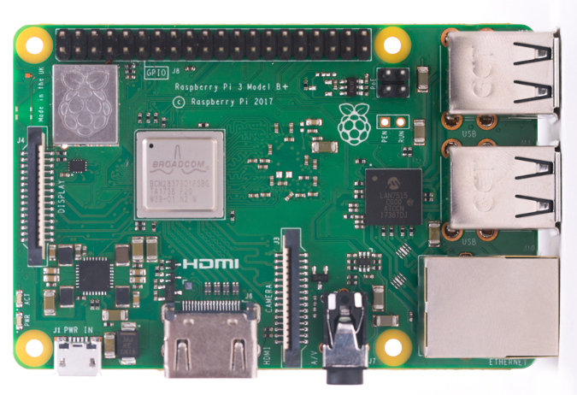

The Raspberry Pi is a very cheap computer that runs Linux, but it also provides a set of GPIO (general purpose input/output) pins that allow you to control electronic components for physical computing and explore the Internet of Things (IoT).

## Raspberry Pi Models

There have been three generations of Raspberry Pi: Pi 1, Pi 2, and Pi 3, and there has generally been a Model A and a Model B of most generations. Model A is a cheaper variant and tends to have reduced RAM and ports like USB and Ethernet. The Pi Zero is a spinoff of the original (Pi 1) generation, made even smaller and cheaper.

### Raspberry Pi B

Release Year: 2013

* ARM CPU, which includes 700MHz Arm1176JZF-S Processor
* 32 bit CPU
* 512 MB RAM
* 2 USB Ports
* 1 HDMI Port
* 26 GPIO Pins
* 1 LAN Port

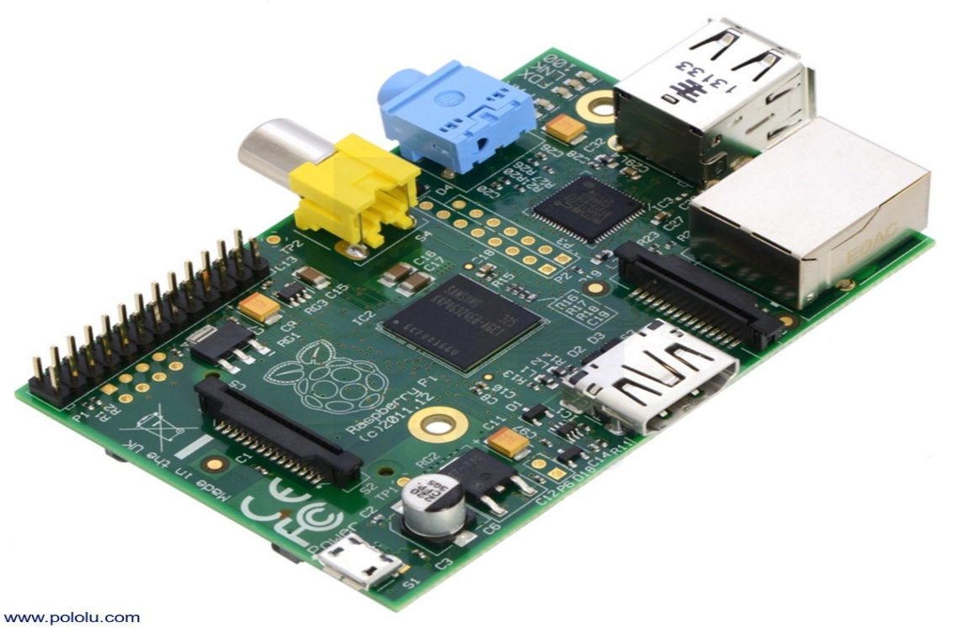

### Raspberry Pi Model A:

Release Year: 2013 (Feb)

* 32 bit, 700MHz ARM ARM1176JZF-S processor core
* 256 MB RAM
* 1 USB Port
* No Ethernet Port
* Composite port, Composite RCA, HDMI (Not at same time)
* 26 GPIO Pins
* Full Sized SD Card Port

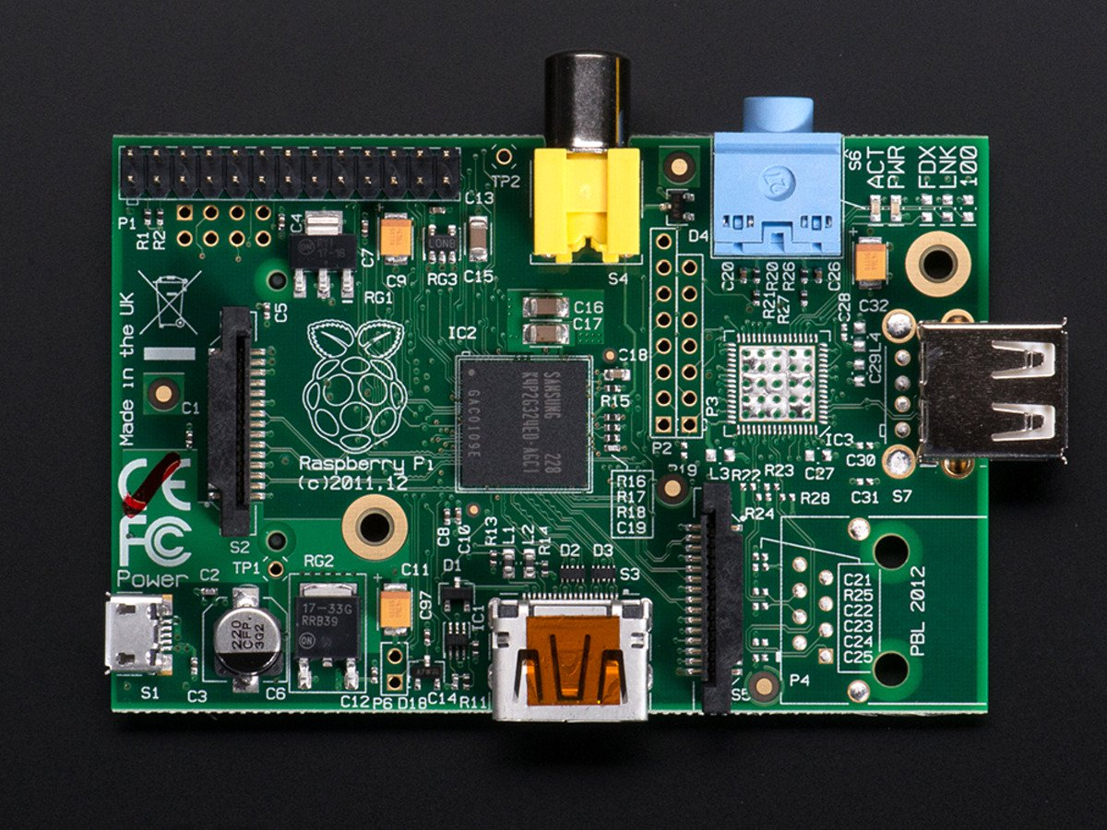

### Raspberry Pi Model A+:

Release Year: 2014 (Nov)

This model is square in shape.

* 32 bit, 700MHz ARM ARM1176JZF-S processor core
* 256 MB RAM
* 1 USB Port
* No Ethernet Port
* 3.5mm Jack for Audio Output
* SD card slot
* 40 GPIO Pins

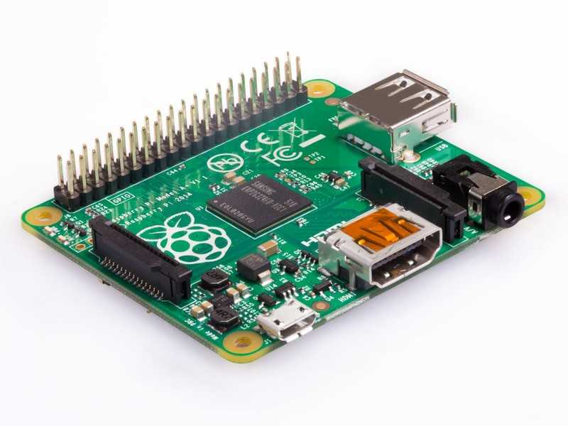

### Raspberry Pi Model B+:

Release Year: 2014

Improved Design

* 32 bit, 700MHz ARM ARM1176JZF-S processor core
* 512 MB RAM
* 4 USB Port
* No Ethernet Port
* HDMI and Composite Video
* 3.5mm Jack
* CSI (Camera) and DSI (Display) connector
* SD card slot
* 40 GPIO Pins

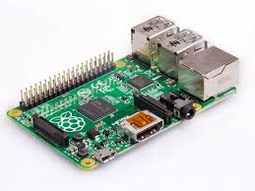

### Raspberry Pi Zero:

Release Year: 2015 (Nov)

Price: $5

* 1GHz ARM ARM1176JZ-F processor core
* 512 MB RAM
* No Ethernet Port
* Mini HDMI Port
* 2.4 GHz Wi-Fi 802.11n(150 Mbps) and Bluetooth 4.1(24 Mbps)
* 1 micro USB OTG
* SD card slot
* 40 GPIO Pins

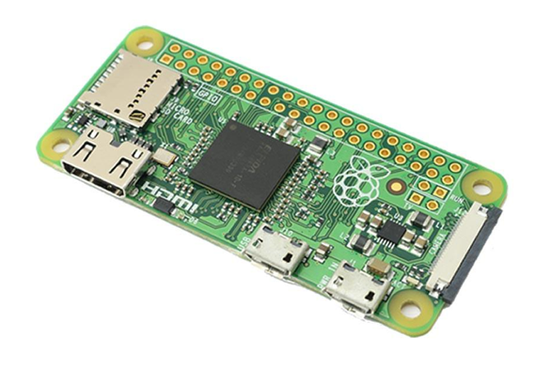

### Raspberry Pi 2 Model B+:

* 900MHz Broadcom BCM2836 quad-core system-on-a-chip
* 32 bit ARM Cortex A7 Processor
* 256/512 MB RAM, to an upgraded 1GB RAM
* 4 USB Port
* 1 Ethernet port
* Combined 3.5mm Audio Jack and Composite Video
* HDMI Port
* Camera Interface and Display Interfacing
* Micro SD card slot
* 40 GPIO Pins

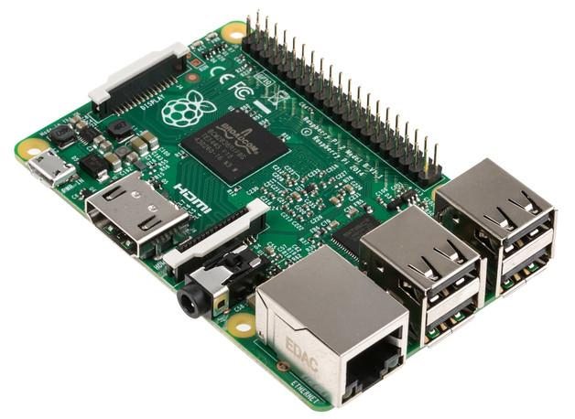

### Raspberry Pi 3 Model B:

Release Year: 2017 (Jan)

* Broadcom BCM2837.
* 4× ARM Cortex-A53, 1.2GHz.
* Broadcom Video Core IV.
* 1 GB RAM
* 10/100 Ethernet, 2.4GHz 802.11n wireless.
* Bluetooth 4.1 Classic, Bluetooth Low Energy.
* Storage: micro SD slot
* 40 GPIO Pins

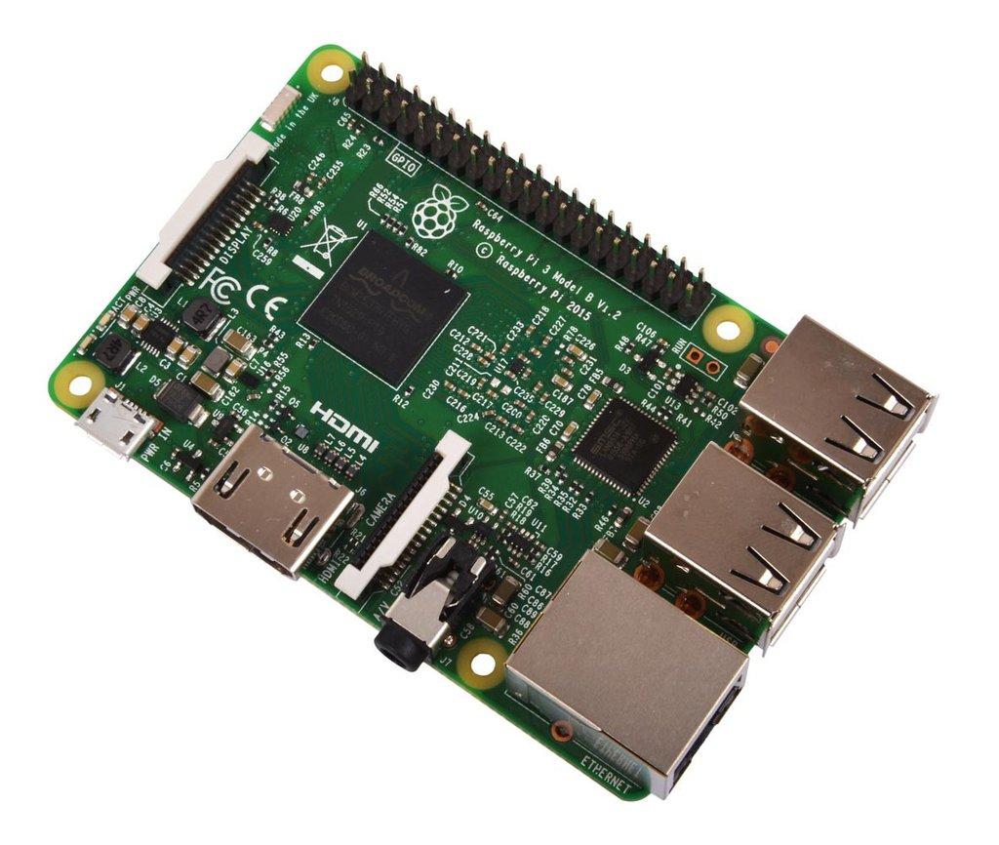

### Raspberry Pi 3 Model B+:

* Broadcom BCM2837B0, Cortex-A53 (ARMv8) 64-bit SoC.
* 1.4GHz 64-bit quad-core ARM Cortex-A53 CPU.
* 1GB LPDDR2 SDRAM.
* Dual-band 802.11ac wireless LAN (2.4GHz and 5GHz) and Bluetooth 4.2.
* Gigabit Ethernet over USB 2.0 (max 300 Mbps)
* Thermal management: Yes.

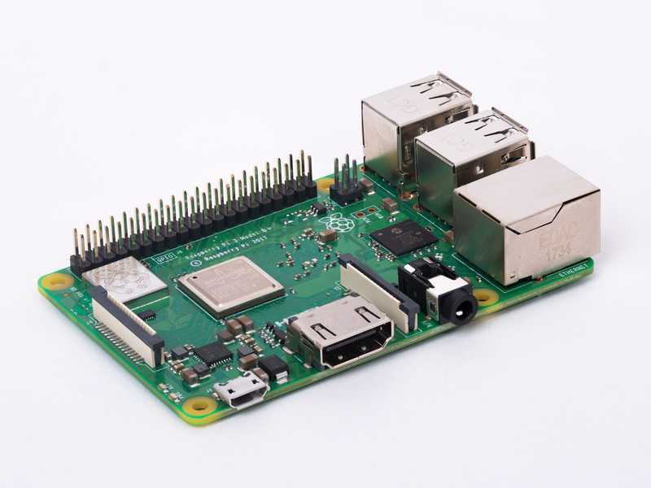

### Comparison:

|  |  |  |  |  |  |  |
| --- | --- | --- | --- | --- | --- | --- |
| Family | Model | Release | Form Factor | Ethernet | Wireless | GPIO |
| Raspberry Pi 1 | B+ | 2014 | Standard  (85.60 × 56.5 mm) | Yes | No | 40-pin |
| Raspberry Pi 1 | B | 2012 | Standard  (85.60 × 56.5 mm) | Yes | No | 26-pin |
| Raspberry Pi 1 | A+ | 2014 | Compact  (65 × 56.5 mm) | No | No | 40-pin |
| Raspberry Pi 1 | A | 2013 | Standard  (85.60 × 56.5 mm) | No | No | 26-pin |
| Raspberry Pi 2 | B | 2015 | Standard | Yes | No | 40-pin |
| Raspberry Pi 3 | B+ | 2018 | Standard | Yes | Yes | 40-pin |
| Raspberry Pi 3 | B | 2016 | Standard | Yes | Yes | 40-pin |
| Raspberry Pi 3 | A+ | 2018 | Compact | No | Yes | 40-pin |
| Raspberry Pi Zero | Zero | 2015 | Zero  (65 × 30 mm) | No | No | 40-pin |
| Raspberry Pi Zero | W/WH | 2017 | Zero  (65 × 30 mm) | No | Yes | 40-pin |

## Installing OS on Raspberry Pi:

Raspberry Pi doesn’t come with an operating system pre-installed. This means you can choose from a wide of OSs, each of which can be flashed to your Raspberry Pi’s SD card. Here’s how to get a new OS installed and running on your Raspberry Pi, using Windows, mac OS, or Linux.

A lot of our tutorials here on The Pi start the same way – with a link to this one. That’s because a huge number of great Raspberry Pi projects start with installing Raspbian on the Raspberry Pi. Raspbian is the Raspberry Pi’s most popular operating system, a spinoff of the Linux distribution Debian that works well on the Raspberry Pi’s hardware. Raspbian is a competent and versatile operating system that gives your Raspberry Pi all the comforts of a PC: a command line, a browser, and tons of other programs. You can use a Raspberry Pi running Raspbian as a cheap and effective home computer, or you can use it as a springboard and turn your Raspberry Pi into any of countless other functional devices, from wireless access points to retro gaming machines. Here’s to install Raspbian on the Raspberry Pi.

Installing Raspbian on the Raspberry Pi is straightforward. We’ll be downloading Raspbian and writing the disc image to a microSD card, then booting the Raspberry Pi to that microSD card. For this project, you’ll need a microSD card (go with at least 8 GB), a computer with a slot for it, and, of course, a Raspberry Pi and basic peripherals (a mouse, keyboard, screen, and power source). This isn’t the only method for installing Raspbian (more on that in a moment), but it’s a useful technique to learn because it can also be used to install so many other operating systems on the Raspberry Pi. Once you know how to write a disc image to a microSD card, you open up a lot of options for fun Raspberry Pi projects.

Ways to install Raspberry Pi: 1. Noobs 2. Raspbian

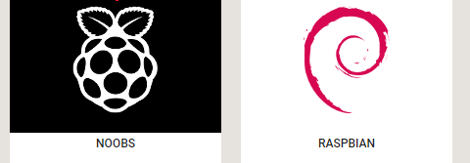

### Downloading NOOBS

Using NOOBS is the easiest way to install Raspbian on your SD card. To get hold of a copy of NOOBS:

1. Visit [www.raspberrypi.org/downloads/](https://www.raspberrypi.org/downloads/)
2. You should see a box with a link to the NOOBS files. Click on the link.
3. The simplest option is to download the zip archive of the files.

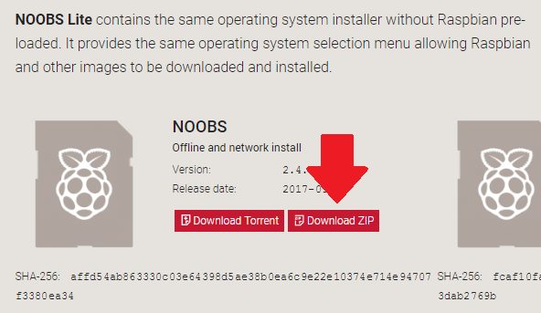

### Formatting the SD Card

If the SD card on which you wish to install Raspbian currently has an older version of Raspbian on it, you may wish to back up the files from the card first, as they will be overwritten during this process. Visit the SD Association’s website and download SD Formatter 4.0 for Windows. Follow the instructions to install the software. Insert your SD card into the computer or laptop’s SD card reader and make a note of the drive letter allocated to it. In SD Formatter, select the drive letter for your SD card, and format it.

### Extracting NOOBS from the zip archive

Next, you will need to extract the files from the NOOBS zip archive you downloaded from the Raspberry Pi website.

Go to your Downloads folder and find the zip file you downloaded.

Extract the files and keep the resulting Explorer/Finder window open.

### Copying the files

Now open another Explorer/Finder window and navigate to the SD card. It’s best to position the two windows side by side.

Select all the files from the NOOBS folder and drag them onto the SD card.

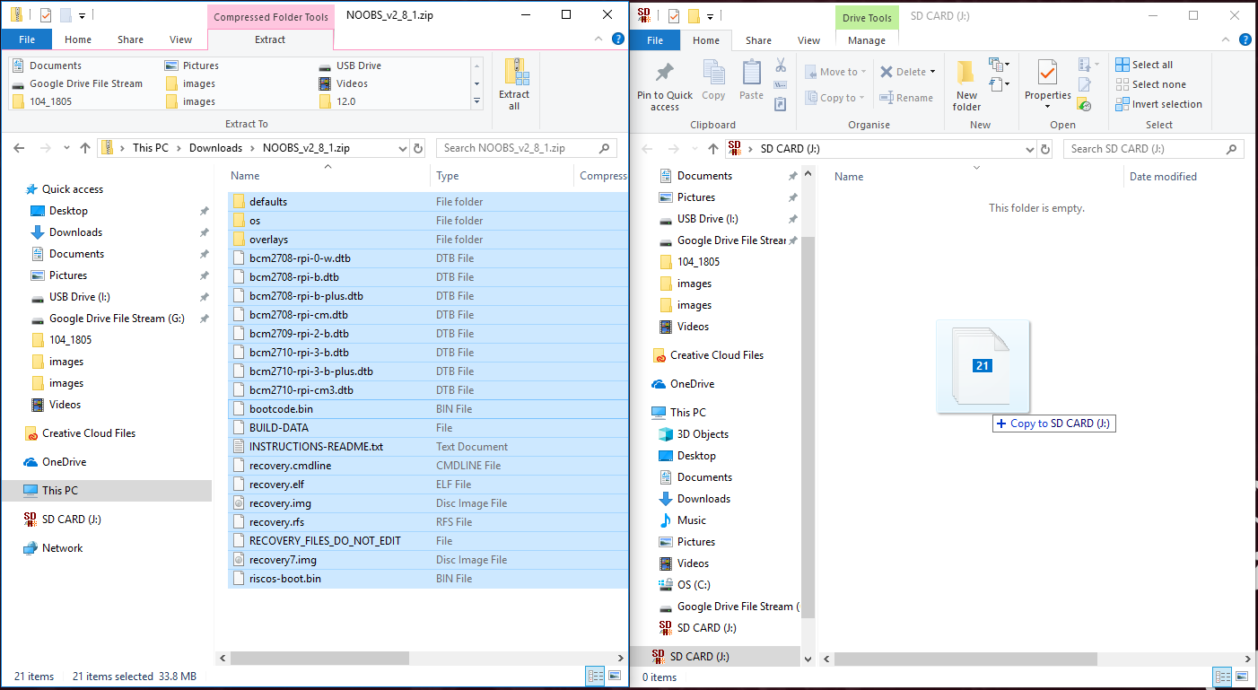

Eject the SD card.

### Booting from NOOBS

Once the files have been copied over, insert the micro SD Card into your Raspberry Pi, and plug the Pi into a power source.

You will be offered a choice when the installer has loaded. You should check the box for **Raspbian**, and then click **Install**.

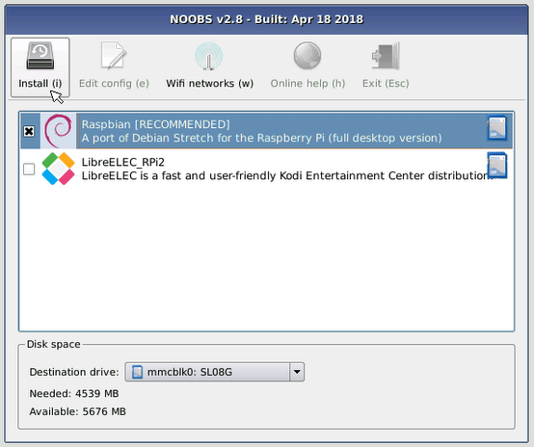

Click **Yes** at the warning dialog, and then sit back and relax. It will take a while, but Raspbian will install.

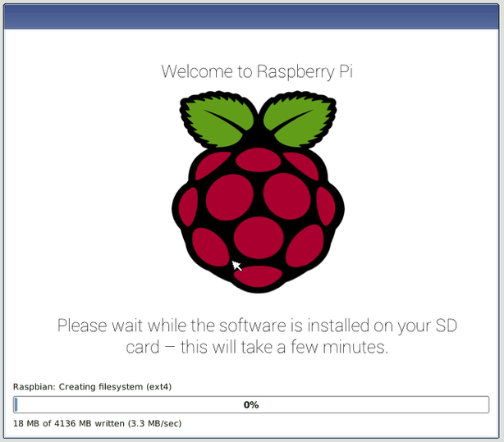

When Raspbian has been installed, click **OK** and your Raspberry Pi will restart and Raspbian will then boot up.

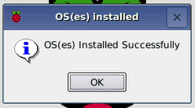

## Configuring Raspberry Pi:

### Using Command Line:

raspi-config is Raspberry pi configuration tool that targets Raspbian. It aims to provide functionality to make the most common configuration changes. This may results in automated edits to /boot/config.txt and various standard Linux configuration files. Some options require a reboot to take effect. If you changed any of those, raspi-config will ask if you wish to reboot now when you select FINISH button.

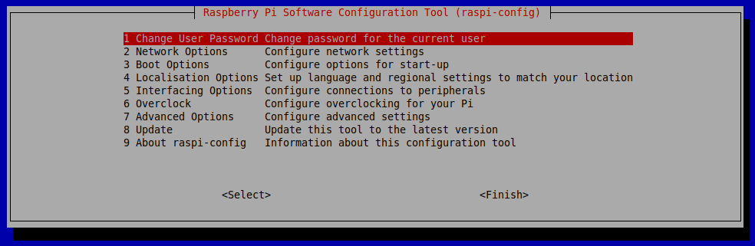

### Graphical Method:

Alternatively, Pi can be configured directly by selecting Raspberry Pi Configuration Preferences in the menu as follows-

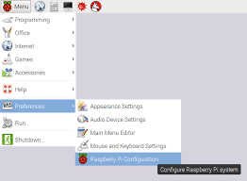

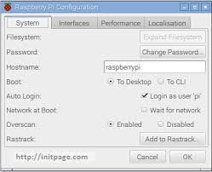

## Raspberry Pi Camera Using Motion

The Raspberry pi is perfectly equipped to turn your USB based web cam into a fully functional IP web cam. This will allow you to create a webcam for your pi so that you can view it from any computer on the local network.

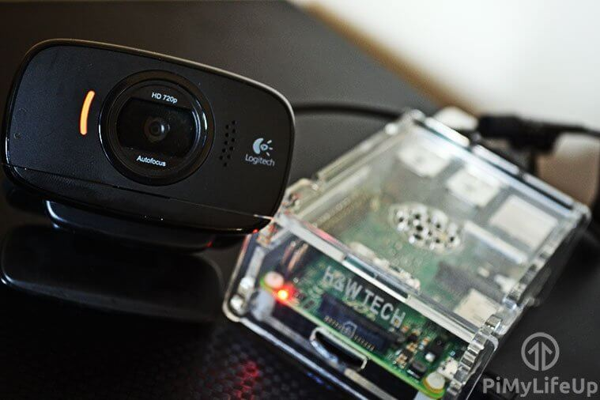

### Components Required:

* Raspberry Pi
* Webcam
* USB Powered Hub

### Setup Pi and Camera:

1. Connect Camera to Raspberry pi.
2. Connect pi with LAN Cable and power it up.
3. Know your IP address. To view it:

* Use ipconfig command. eth0 is used for attached Ethernet cable.
* ipconfig eth0.

1. Connect pi by SSH connection (PUTTY). Open Putty and type IP Address of your pi and connect pi. ‘pi’ as your default username and ‘raspberry’ as your default password.

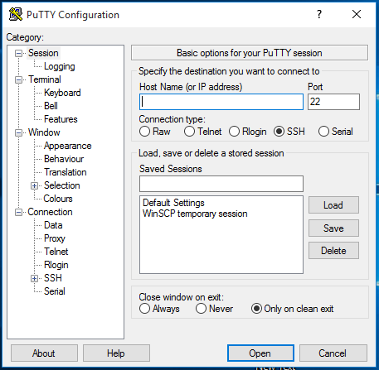

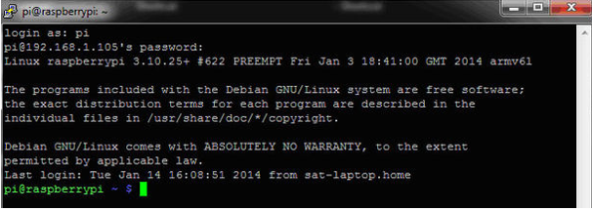

1. To begin, first, update Raspberry Pi, so you’re running on the latest version.

sudo apt-get update

sudo apt-get upgrade

sudo apt-get install motion

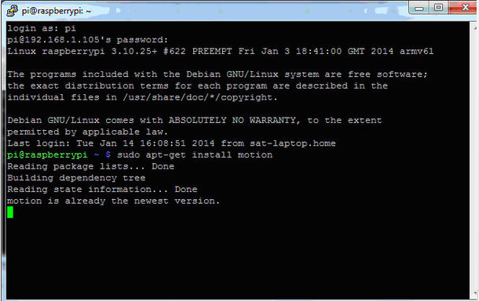

1. Now we need to make some edits to the configuration file, motion.conf.

sudo nano /etc/motion/motion.conf

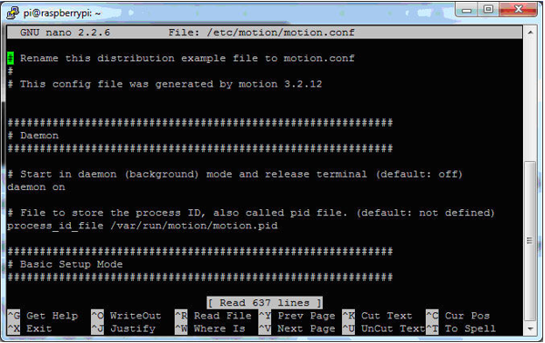

* Make sure 'daemon' is ON.
* Set 'framerate' anywhere in between 1000 to 1500.
* Keep 'Stream_port' to 8081.
* 'Stream_quality' should be 100.
* Change 'Stream_localhost' to OFF.
* Change 'webcontrol_localhost' to OFF.
* Set 'quality' to 100.
* Set 'width' & 'height' to 640 & 480.
* Set 'post_capture' to 5.
* Press ctrl + x to exit. Type y to save and enter to confirm.
* Again type in the command 'sudo nano /etc/default/motion ' and press enter.
* Set ' start_motion_daemon ' to yes. Save and exit.

1. Now make sure the camera is connected and run the following line:

sudo service motion start

1. If you need to stop the service, simply run the following command:

sudo service motion stop

1. sudo motion.

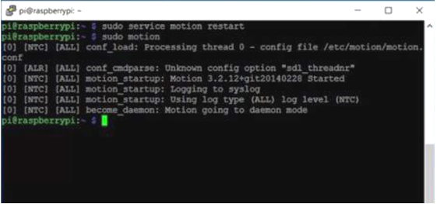

1. Now to see the streaming open Mozilla Firefox.
2. Type in URL ‘about:config’ then make a new string.
3. Then type ‘network security port banned override’ and the port number that mentioned in motion conf file.
4. In pi, run motion and in firefox write “your ip: port number”.
5. Now the streaming is visible to you.

# WINSCP:

WinSCP (Windows Secure Copy) is a free and open-source SFTP, FTP, WebDAV, Amazon S3 and SCP client for Microsoft Windows. Its main function is secure file transfer between a local and a remote computer. Beyond this, WinSCP offers basic file manager and file synchronization functionality. For secure transfers, it uses Secure Shell (SSH) and supports the SCP protocol in addition to SFTP.

If you are going to use Raspbian for the first time, Make sure that you enabled the SSH command in raspi-config.

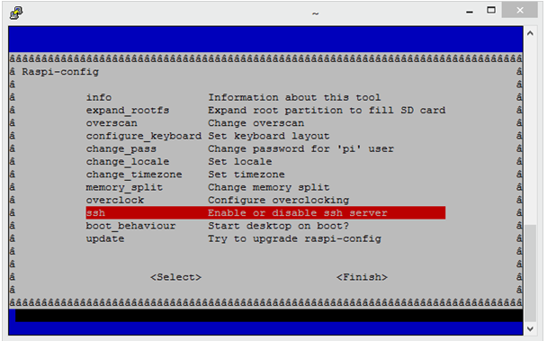

## Installation:

1. Download the WinSCP Installation package.
2. Run the WinSCP Installer as you would any other Windows program.
3. When prompted, choose Typical installation as the Setup type.

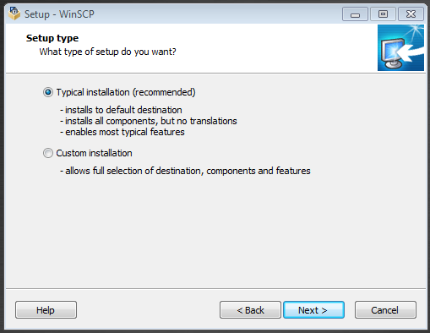

1. When prompted, choose Explorer as the preferred user interface option.

* If you are used to Norton Commander (used by several contemporary file managers like Total Commander, FAR, and Altap Salamander), choose Commander as the preferred user interface. Commander is primarily focused on easy keyboard control—you can use it without ever touching your mouse.

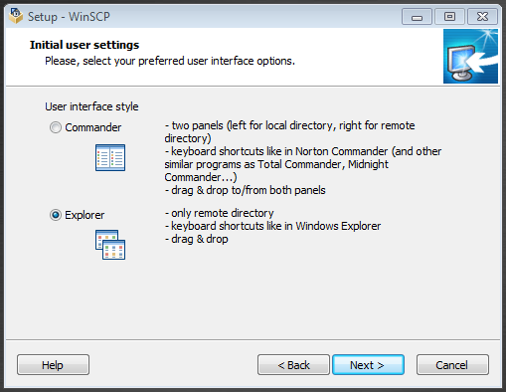

1. Complete the installation and restart your computer.

## Connecting:

 The first time **WinSCP** is opened there will be a blank Login area (left). After clicking on **New Site**, supply all the details of the Raspberry Pi in the Session area. The IP address of the Raspberry Pi is saved under **Host name**, the **File protocol** should be set to **SCP** and the**Port number** should be left as **22**. After selecting **Save, WinSCP** will prompt for a **Site name** and the option to save the password.

[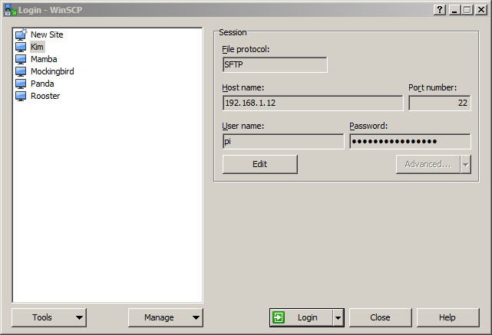](https://www.behind-the-scenes.co.za/wp-content/uploads/using-winscp-to-connect-to-a-raspberry-pi.jpg)

By double clicking on the **Site name** on the Login area, **WinSCP** terminal will open. After the first time the security key will be created upon acceptance.

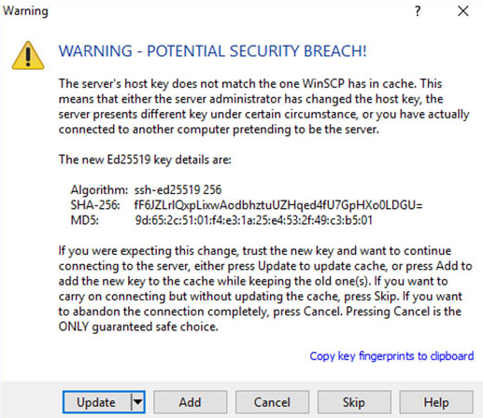

For Raspbian, the default username and password is **pi** and **raspberry**. Multiple saved Logins to different devices can be created.

The settings can be changed by selecting the applicable saved Login and **Edit**. After changing the settings it needs to be saved again.

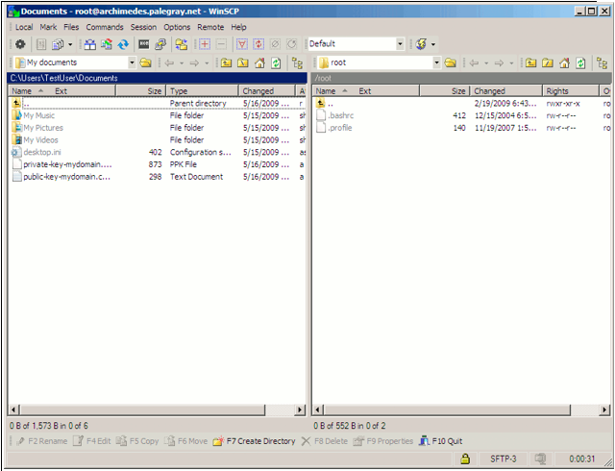

## Remote Access

Sometimes you need to access a Raspberry Pi without connecting it to a monitor. Perhaps the Pi is embedded in something like a robot, or you may want to view some information from it from elsewhere. Maybe you simply don't have a spare monitor! You can find more information on accessing your Raspberry Pi remotely here.

You can access the command line of a Raspberry Pi remotely from another computer or device on the same network using SSH.

The Raspberry Pi will act as a remote device: you can connect to it using a client on another machine.

You only have access to the command line, not the full desktop environment. For a full remote desktop, see VNC.

### Set up wireless connectivity

Make sure your Raspberry Pi is properly set up and connected. If you are using wireless networking, this can be enabled via the desktop's user interface, or using the command line. If you are not using wireless connectivity, plug your Raspberry Pi directly into the router. You will need to note down the IP address of your Pi in order to connect to it later. Using the ifconfig command will display information about the current network status, including the IP address, or you can use hostname -I to display the IP addresses associated with the device.

### Enable SSH

Raspbian has the SSH server disabled by default. It can be enabled manually from the desktop:

* Launch Raspberry Pi Configuration from the Preferences menu
* Navigate to the Interfaces tab
* Select Enabled next to SSH
* Click OK
* Alternatively, raspi-config can be used in the terminal:
* Enter ‘sudo raspi-config’ in a terminal window
* Select Interfacing Options
* Navigate to and select SSH
* Choose Yes
* Select Ok
* Choose Finish
* Alternatively, use systemctl to start the service.
* sudo systemctl enable ssh
* sudo systemctl start ssh

When enabling SSH on a Pi that may be connected to the internet, you should change its default password to ensure that it remains secure. See the Security page for more details.

### Installing SSH client on your computer:

Install an SSH client if you do not have one already. We recommend using “Putty” (http://www.putty.org/) for this workshop. Please download Putty from the web page and open it in your laptop.

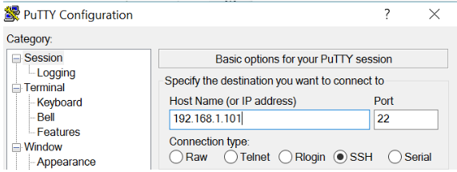

When prompted, type in “pi” as your user name and “raspberry” as your password.

You will get a security message when you log in for the first time.

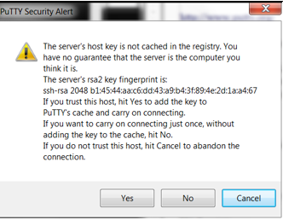

Now Login into pi as usual.

# GPIO & Raspberry Pi:

## Introduction

GPIO stands for General Purpose Input Output. The Raspberry Pi has two rows of GPIO pins, which are connections between the Raspberry Pi, and the real world. Output pins are like switches that the Raspberry Pi can turn on or off (like turning on/off a LED light). But it can also send a signal to another device. Input pins are like switches that you can turn on or off from the outside world (like a on/off light switch). But it can also be a data from a sensor, or a signal from another device. That means that you can interact with the real world, and control devices and electronics using the Raspberry PI and its GPIO pins!

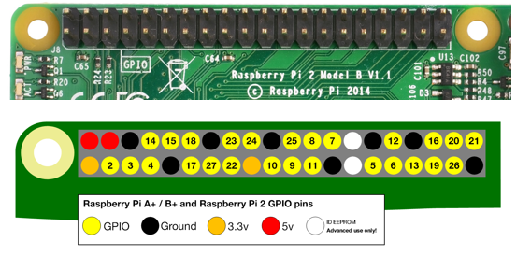

The GPIO is the most basic, yet accessible aspect of the Raspberry Pi. GPIO pins are digital which means they can have two states, off or on. They can have a direction to receive or send current (input, output respectively) and we can control the state and direction of the pins using programming languages such as Python, JavaScript, node-RED etc. The operating voltage of the GPIO pins is 3.3v with a maximum current draw of 16mA. This means that we can safely power one or two LEDs (Light Emitting Diodes) from a single GPIO pin, via a resistor. But for anything requiring more current, a DC motor for example, we will need to use external components to ensure that we do not damage the GPIO. Controlling a GPIO pin with Python is accomplished by first importing a library of pre-written code. The most common library is RPi.GPIO (https://pypi.org/project/RPi.GPIO/) and it has been used to create thousands of projects since the early days of the Raspberry Pi. In more recent times a new library called GPIO Zero (https://pypi.org/project/gpiozero/)has been introduced, offering an easier entry for those new to Python and basic electronics. Both of these libraries come pre-installed with the Raspbian operating system.

GPIO pins have multiple names; the first most obvious reference is their “physical” location on the GPIO. Starting at the top left of the GPIO, and by that we mean the pin nearest to where the micro SD card is inserted, we have physical pin 1 which provides 3v3 power. To the right of that pin is physical pin 2 which provides 5v power. The pin numbers then increase as we move down each column, with pin 1 going to pin 3, 5,7 etc until we reach pin 39. You will quickly see that each pin from 1 to 39 in this column follows an odd number sequence. And for the column starting with pin 2 it will go 4,6,8 etc until it reaches 40. Following an even number sequence. Physical pin numbering is the most basic way to locate a pin, but many of the tutorials written for the Raspberry Pi follow a different numbering sequence.

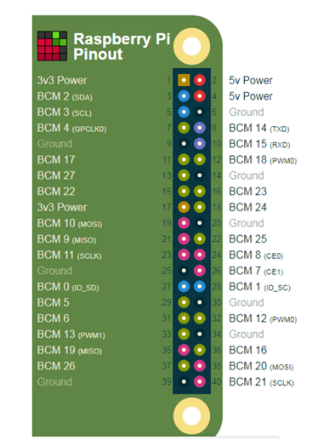

Broadcom (BCM) pin numbering (aka GPIO pin numbering) seems to be chaotic to the average user. With GPIO17, 22 and 27 following on from each other with little thought to logical numbering. The BCM pin mapping refers to the GPIO pins that have been directly connected to the System on a Chip (SoC) of the Raspberry Pi. In essence we have direct links to the brain of our Pi to connect sensors and components for use in our projects.

You will see the majority of Raspberry Pi tutorials using this reference and that is because it is the officially supported pin numbering scheme from the Raspberry Pi Foundation. So it is best practice to start using and learning the BCM pin numbering scheme as it will become second nature to you over time. Also note that BCM and GPIO pin numbering refer to the same scheme. So for example GPIO17 is the same as BCM17. Certain GPIO pins also have alternate functions that allow them to interface with different kinds of devices that use the I2C, SPI or UART protocols. For example GPIO3 and GPIO 4 are also SDA and SCL I2C pins used to connect devices using the I2C protocol. To use these pins with these protocols we need to enable the interfaces using the Raspberry Pi Configuration application found in the Raspbian OS, Preferences menu.

Raspberry Pi’s GPIO as a Data Bus  
The first thing to get your head around, is how is data moved around the RPi, or in any general purpose computer.  In the most general sense in electronics, a bus or data bus is used to move data words of any type from one place to another. Computing is based on data words made up of collections of data bits. These “words” can contain as few as four data bits and often much larger.

The task of a bus designer is to devise circuitry that passes these data words from one circuit to another.  These words can be communicated serially or in parallel.

Serial Bus**:** The least expensive method in terms of wire cost is to send the bits one at a time over a single pair of wires. This is called serial data transmission.  Data words start as sets of bits that exist in parallel. In order to ship these words on a serial basis they must be converted to a serial stream of bits at the transmit end and then reconverted to a parallel word at the receive end. The common name for the circuitry that does this conversion is a [SerDes](http://www.eetimes.com/design/analog-design/4207765/The-basics-of-SerDes--serializers-deserializers--for-interfacing) circuit which stands for serializer /deserializer. Integrated circuits are more expensive when they have more pins. To reduce the number of pins in a package, many ICs use a serial bus to transfer data when speed is not important. Some examples of such low-cost serial buses include [Serial Peripheral Interface (SPI)](http://en.wikipedia.org/wiki/Serial_Peripheral_Interface), [Inter-Integrated Circuit (I²C)](http://en.wikipedia.org/wiki/I%C2%B2C), [UNI/O](http://en.wikipedia.org/wiki/UNI/O), and [1-Wire](http://en.wikipedia.org/wiki/1-Wire).

Parallel Bus**:** At some point, it is more cost effective to add a wire for each bit in the word and send it in parallel on a data bus. Parallel buses have a limited data rate and distance at which they can be reliably run (more so than a serial bus).  Some widely used parallel bus standards are [Parallel Bus Interface](http://en.wikipedia.org/wiki/Parallel_Bus_Interface) (PBI), [Peripheral Component Interface](http://en.wikipedia.org/wiki/Conventional_PCI) (PCI), [Small Computer Systems Interface](http://en.wikipedia.org/wiki/Small_Computer_Systems_Interface) (SCSI), the [VMEbus](http://en.wikipedia.org/wiki/VMEbus) used in instrumentation, the [Rambus](http://en.wikipedia.org/wiki/RDRAM) interface used in memories, and others.

As the name implies, GPIO pins can be configured through software to provide some specific function or purpose within the hardware device design.  The GPIO pins connect directly into the core of the processor, and the Raspberry Pi developers implemented several alternate functions for the GPIO pins.  Several are desirable because of the multiple standards and types of devices you may wish to interface.  On boot-up, the RPi board GPIO is in alternate function state “ALT0” and will support I2C, SPI, and UART.  This is shown below:

[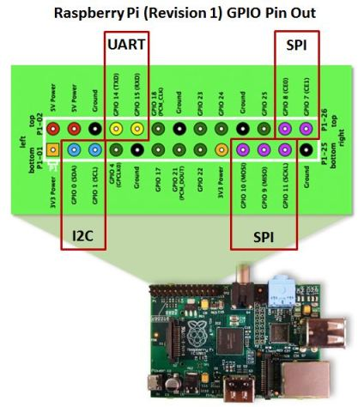](https://jeffskinnerbox.wordpress.com/2012/12/05/drive-a-16x2-lcd-with-the-raspberry-pi/raspberry-pi-rev-1-gpio-pin-out-2/#main)

It can be confusing to call the RPi’s whole 26 pin array GPIO and also some specific pins GPIO.   In reality, all the GPIO pins can be reconfigured to provide alternate functions. While PCM isn’t a topic for this posting, in the figure above, you’ll also see references to PCM on pins 18 & 21.  PCM stands for Pulse Code Modulation and is a method used to digitally represent analog signals.  It is often used to control light intensity or motors.  RPi’s native PCM capabilities are not well documented but it appears that people have has some success.  Generally, to do anything useful, you need multiple PCM channels so people have resorted to adding hardware and software to get the desired functionality from the RPi.  My guess is these RPi pins don’t have much of a future.

Much has been lightly covered so far, including terms like I2C, SPI, and UART.  So what is the significance?  Well, I2C, SPI, and UART are the heart of our quest to understand RPi’s serial communications capability. Via their exposure on the GPIO pins, these capabilities are what can be used to integrate things like LCD displays to the RPi.  Now lets dive deeper into each one of them.

### Universal Asynchronous Receiver/Transmitter (UART)

The UART takes bytes of data and transmits the individual bits in a sequential fashion. The device changes processor’s parallel information to serial data which can be sent on a communication line. A second UART (maybe on another processor) can be used to receive the serial information. The UART performs all the tasks, timing, parity checking, etc. needed for the communication. The only extra devices attached are line driver chips capable of transforming the TTL level signals (0/5 volts) to line voltages (on RS-232 line this could be as +/- 25 volts) and vice versa.

Each UART contains a shift register, which is the fundamental method of conversion between serial and parallel forms. Serial transmission of digital information (bits) through a single wire or other medium is much more cost effective than parallel transmission through multiple wires.  The UARTs transmit/receive one bit at a time at a specified data rate (i.e. 9600bps, 115,200bps, etc.). This method of serial communication is sometimes referred to as TTL serial communications.

Asynchronous transmission allows data to be transmitted without the sender having to send a clock signal to the receiver. Instead, the sender and receiver must agree on timing parameters in advance and special bits are added to each word which are used to synchronize the sending and receiving units. When a word is given to the UART for Asynchronous transmissions, a bit called the “Start Bit” is added to the beginning of each word that is to be transmitted. The Start Bit is used to alert the receiver that a word of data is about to be sent, and to force the clock in the receiver into synchronization with the clock in the transmitter.

For a further description of synchronous and asynchronous line communications,

### Raspberry Pi’s Mini-UART

The Raspberry Pi actually has [two UARTs](http://lavalink.com/2012/04/more-on-raspberry-pi-serial-ports/). One UART is part of the internal ARM architecture of the Broadcom BCM2835 chip, in the core of the Raspberry Pi and not accessible externally.  The other UART is sometimes called the RPi’s “Serial Port” (even thou the USB supports serial communications, and therefore a serial port).  The serial port being reference here is serviced by a UART, sometime referred to as the “[Mini-UART](http://www.raspberrypi.org/wp-content/uploads/2012/02/BCM2835-ARM-Peripherals.pdf)” since it doesn’t appear to be very rich in functionality.  It is basically be used as a console port for access to the Raspberry Pi.  The [serial console](http://www.techrepublic.com/blog/opensource/learn-to-use-a-serial-console-on-linux/157) is a convenient way to interact with the Raspberry Pi for debugging or your network is down and it is the destination of console messages (including boot-up messages).  From the [Raspberry Pi pinout](http://elinux.org/RPi_Low-level_peripherals) and the [eLinux wiki](http://elinux.org/RPi_Serial_Connection), I can see that the serial port (aka Mini-UART) on the Pi is on GPIO Pin 14 (TX) and GPIO Pin 15 (RX):

[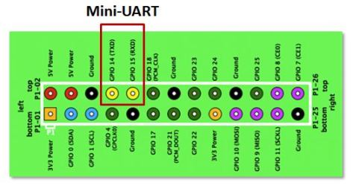](https://jeffskinnerbox.wordpress.com/2012/12/05/drive-a-16x2-lcd-with-the-raspberry-pi/mini-uart/#main)

Since the GPIO pins give access to the Mini UART, you can establish a serial console, which can be used to log in to the Pi, and many other things.  However, normal console device communicate with -12V (logical “1″) and +12V (logical “0″) RS-232, which may just fry something in the 3.3V Pi. Even “TTL level” serial at 5V runs the same risk.

You can reconfigure the RPi so that the Mini UART isn’t acting as a serial console and use it for outer purposes (e.g. communicate with an attached Arduino or Xbee).  [Using the Raspberry Pi’s serial port](http://www.irrational.net/2012/04/19/using-the-raspberry-pis-serial-port/) requires some Linux reconfiguration and the abandonment of the serial console, and potentially some level conversion, but it could be useful. The Mini-UART pins to provide access to Linux’s [/dev/ttyAMA0](http://www.raspberrypi.org/phpBB3/viewtopic.php?f=44&t=13957) serial port.  To be able to use the serial port to connect and talk to other devices, the serial port console login needs to be disabled and the post “[Raspberry Pi and the Serial Port](http://www.hobbytronics.co.uk/raspberry-pi-serial-port)” shows you how.

Again, keep in mind that RX and TX lines are available on the [GPIOs](http://elinux.org/RPi_Low-level_peripherals) but operate at 3.3 volts. You’ll need a board or cable to[level convert](http://www.adafruit.com/products/395) 3.3 volt UART signals to connect with other devices (e.g. RS-232, USB).

### Serial Peripheral Interface Bus (SPI) — aka 4-Wire Serial Bus

The [Serial Peripheral Interface Bus or SPI](http://www.eeherald.com/section/design-guide/esmod12.html) (pronounced as either S-P-I or spy) bus is a synchronous serial data link standard, named by Motorola, that operates in full duplex mode.  SPI is much simpler than I2C. Master and slave are linked by three data wires, usually called MISO, (Master in, Slave out), MOSI (Master out, Slave in), the SCLK clock line (sometimes called M-CLK), and an optional SS (Slave Select; sometimes known as the Chip Select or CS line orChip Enable or CE line) is the slave select or chip select line.  It is optional only if you have one slave, otherwise one or more SS lines are provided.  The Raspberry Pi has two [Slave Select](http://en.wikipedia.org/wiki/Chip_select) lines: CE0 and CE1.

[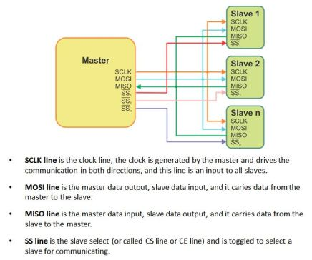](https://jeffskinnerbox.wordpress.com/2012/12/05/drive-a-16x2-lcd-with-the-raspberry-pi/spi-diagram-and-sescription/#main)

Usually the transfer sequence consist of driving the SS line low, sending X number of clock signals with the proper polarity and phase, then driving the SS line high to end the communication. As the clock signals are generated, data is transferred in both directions, therefore in a “transmit only” system the received bytes have to be discarded and in a “receive only” system a dummy byte has to be transmitted.

Many SPI-enabled ICs and Microcontrollers can cope with data rates of over 10MHz, so transfer is much faster than with I2C. Since it is [synchronous communications](http://www.fiberoptics4sale.com/wordpress/what-is-synchronous-transmission-and-asynchronous-transmission/), it is not limited to 8-bit words so you can send any message sizes with arbitrary content and purpose. The SPI interface does not require pull-up resistors, which translates to lower power consumption. The downside is that SPI normally has no addressing capability; instead, devices are selected by means of a SS signal which the master can use to enable one slave out of several connected to the SPI bus. If more than one slave exists, one chip select line is required per device, which can use precious GPIO lines on the Master.

### Inter-Integrated Circuit (I2C) — aka 2-Wire Serial Bus

[Inter-Integrated Circuit or I2C](http://www.eeherald.com/section/design-guide/esmod11.html) (pronounced as either I-squared-C or I-2-C) is generically referred to as a “two-wire interface”.  It’s a multi-master serial single-ended computer bus invented by Philips that is used to attach low-speed peripherals to a motherboard, embedded system, cellphone, or other electronic device.

I2C can be used to connect up to 127 nodes via a bus has two data wires, called SCL and SDA.  SCL is the clock line. It is used to synchronize all data transfers over the I2C bus. SDA is the data line. Of course, there is a third wire being ground. There may also be a 5 volt wire to distribute power to the devices. Both SCL and SDA lines are “open drain” drivers. What this means is that the chip can drive its output low, but it cannot drive it high.  For the line to be able to go high you must provide pull-up resistors to the 5v supply. There should be a resistor from the SCL line to the 5v line and another from the SDA line to the 5v line. The value of the resistors is not critical.  Anything from 1800 ohms to 47K ohms used (1.8K, 47K and 10K are common values). You only need one set of pull-up resistors for the whole I2C bus, not for each device, as illustrated below:

[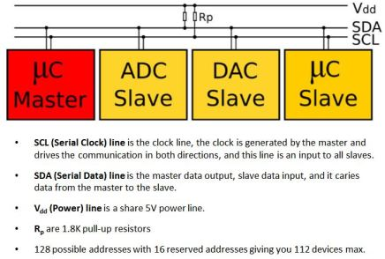](https://jeffskinnerbox.wordpress.com/2012/12/05/drive-a-16x2-lcd-with-the-raspberry-pi/i2c-diagram-and-description-2/#main)

In theory the I2C bus can support multiple masters, but most micro-controllers can’t. A master is usually a microcontroller, although it doesn’t have to be. Slaves can be ICs or microcontrollers.  When the master wishes to communicate with a slave it sends a series of pulses down the SDA and SCL lines. The data that is sent includes an address that identifies the slave with which the master needs to interact. Addresses take 7 bits out of a data byte; the remaining bit specifies whether the master wishes to read (get data from a slave) or write (send data to a slave). Some devices have an address that is entirely fixed by the manufacturer; others can be configured to take one of a range of possible addresses. When a micro-controller is used as a slave it is normally possible to configure its address by software, and for that address to take on any of the 127 possible values.  The address byte may be followed by one or more bytes of data, which may go from master to slave or from slave to master. When data is being sent on the SDA line, clock pulses are sent on the SCL line to keep master and slave synchronized. Since the data is sent one bit at a time, the data transfer rate is one eighth of the clock rate. The original standard specified a standard clock rate of 100KHz, and most I2C chips and micro-controllers can support this. Later updates to the standard introduced a fast speed of 400KHz and a high speed of 1.7 or 3.4 MHz.  The Arduino and Raspberry Pi can support standard and fast speeds.

The fast rate corresponds to a data transfer rate of 50K bytes/sec which is too slow for some control applications. One option in that case is to use SPI instead of I2C.

### 1-Wire — aka 1-Wire Serial Bus

On a [1-Wire](http://www.maximintegrated.com/products/1-wire/flash/overview/index.cfm)bus (sometime refered to as a “MicroLan”), a single master device communicates with one or more 1-Wire slave devices over a single data line, which can also be used to provide power to the slave devices. Devices drawing power from the 1-wire bus are said to be operating inparasitic power mode.  When operating in parasite power mode, only two wires are required: one data wire, and ground. At the master, a 4.7k pull-up resistor must be connected to the 1-wire bus. With an external supply, three wires are required: the bus wire, ground, and power. The 4.7k pull-up resistor is still required on the bus wire.

REPORT THIS AD

[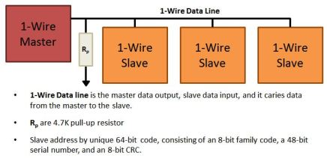](https://jeffskinnerbox.wordpress.com/2012/12/05/drive-a-16x2-lcd-with-the-raspberry-pi/1-wire-diagram-and-description/#main)

Each 1-Wire device contains a unique 64-bit code, consisting of an 8-bit family code, a 48-bit serial number, and an 8-bit CRC. Before sending a command to a slave device, the master must first select that device using its code.

### How do you use I2C, SPI, UART, or 1-Wire on the Raspberry Pi?

Now that we know thewhat & why for serial communications options on the Raspberry Pi, how do we use them?  This topic deserves technical details and examples but this post has already run too long.  I’m likely to do some specific implementation in the future, but for now I’ll reference some sources of information on the web.

First, let’s be clear about the RPi software distribution I’m using, since not all will be supporting all these serial communications options.  I’m using Adafruit’s [Occidentalis](http://learn.adafruit.com/adafruit-raspberry-pi-educational-linux-distro/occidentalis-v0-dot-2) distribution (based on “Wheezy”) which comes with hardware SPI, I2C, and 1-wire support. In the Occidentalis distribution, Adafruit has included in the Linux [kernel](http://en.wikipedia.org/wiki/Kernel_(computing)#Unix) the needed drivers. SPI and I2C has been implement on the GPIO pins as outline above.  RPi doesn’t have a predetermined GPIO pin assignment for 1-Wire, but Adafruit choose GPIO pin 4 for 1-Wire.  Note that this unassigned GPCLK0 (General Purpose Clock Voltage) function.

Given you have the Occidentalis distribution, you can check on the installation of I2C, SPI, and 1-Wire via the following:

* To validate I2C, connect any I2C device to power, ground, SDA and SCL. Then run  sudo i2cdetect -y 0 to detect which addresses are on the bus. [i2cdetect](http://linux.die.net/man/8/i2cdetect) is a program to scan an I2C bus for devices.  Also, you can list the I2C device drivers via the command ls /dev/*i2c*.  This illustrates that RPi supports two I2C buses, 0 and 1.
* To validate SPI, the command ls /dev/*spi* will list two SPI devices, one each for the 0 & 1 SS lines.  To go further, use the [spidev_test.c](http://git.kernel.org/?p=linux/kernel/git/torvalds/linux.git;a=blob_plain;f=Documentation/spi/spidev_test.c) tool described in [Getting SPI working on the Raspberry Pi](http://www.brianhensley.net/2012/07/getting-spi-working-on-raspberry-pi.html).
* Occidentalis implementation of 1-Wire isn’t done via a kernel installed driver but [bit banged](http://en.wikipedia.org/wiki/Bit_banging). Adafruit states that the implementation is “[flakier than SPI or I2C](http://learn.adafruit.com/adafruit-raspberry-pi-educational-linux-distro/occidentalis-v0-dot-1#one-wire-support)” and they don’t have any tutorials.  Maybe 1-Wire should be shelved for now.

There are some good RPi SPI & I2C tutorials on Adafruit.

# Python

Python is an interpreted, high-level, general-purpose programming language. Created by Guido van Rossum and first released in 1991, Python's design philosophy emphasizes code readability with its notable use of significant whitespace. Its language constructs and object-oriented approach aim to help programmers write clear, logical code for small and large-scale projects.

Python is dynamically typed and garbage-collected. It supports multiple programming paradigms, including procedural, object-oriented, and functional programming. Python is often described as a "batteries included" language due to its comprehensive standard library.

## PIP

pip is a de facto standard package-management system used to install and manage software packages written in Python.[4] Many packages can be found in the default source for packages and their dependencies — Python Package Index (PyPI).

Most distributions of Python come with pip preinstalled. Python 2.7.9 and later (on the python2 series), and Python 3.4 and later include pip (pip3 for Python 3) by default. pip is a recursive acronym for "Pip Installs Packages".

One major advantage of pip is the ease of its command-line interface, which makes installing Python software packages as easy as issuing a command:

**pip install some-package-name**

Users can also easily remove the package:

**pip uninstall some-package-name**

## Python Development Tools

To program GPIO pins of Raspberry pi with python, there is a GPIO python library that is made available. So run the following commands to install basic development python tool.

Sudo apt-get update

Apt-get install python-dev python pip

Pip install python

## Install GPIO Library

The RPi.GPIO Python library allows you to easily configure and read-write the input/output pins on the Pi’s GPIO header within a Python script. Thankfully this library is now including in the standard Raspbian image available from the Foundations Download Page.

If you are using a fresh image you don’t need to install it but I’ve kept the instructions here in case you ever want to try a manually installation.

### Install from repository

If the package exists in the Raspbian repository is can be installed using apt-get. First you need to update the available package versions

sudo apt-get update

Then attempt to install the RPi.GPIO package:

sudo apt-get install rpi.gpio

If it isn’t already installed it will be installed. If it is already installed it will be upgraded if a newer version is available.

### Manual Installation

The package is available from http://pypi.python.org/pypi/RPi.GPIO and the current version is 0.5.11 (February 2015). If this version is updated you will need to make appropriate changes to the version number in the commands below.

1. Download the library

wget https://pypi.python.org/packages/source/R/RPi.GPIO/RPi.GPIO-0.5.11.tar.gz

1. Extract the archive to a new folder

tar -xvf RPi.GPIO-0.5.11.tar.gz

1. Browse to the new directory

cd RPi.GPIO-0.5.11

1. Install the library

sudo python setup.py install

1. Remove the directory and archive file

cd ~

sudo rm -rf RPi.GPIO-0.*

This will now mean you can use the library within Python.

# Sublime Text

Sublime Text is a proprietary cross-platform source code editor with a Python application programming interface (API). It natively supports many programming languages and markup languages, and functions can be added by users with plugins, typically community-built and maintained under free-software licenses.

### Configuration

When it comes to secure file transfer, one or the other of you should probably have heard of the SFTP-client named WinSCP. WinSCP enables the secure transfer of data between two computers based on either the SSH protocol or the SFTP protocol and provides, as also many of the normal FTP-clients do, the functionality of editing files directly on the server (respectively edit them direct out of the WinSCP interface without the premise to manually download the files before editing).

Unfortunately WinSCP will open all text files in his own simple style editor. But if you want to edit script files like PHP scripts, which is what I want to do most times, you will miss the comfort of a good text editor like Notepad++ or Sublime Text. But don’t worry – there’s a solution also for this problem, so that you don’t have to give up your beloved features like syntax highlighting and autocomplete. How to connect WinSCP with the editor of you choice is what I’ll show to you in the following sentences. (For this article we pretend Notepad++ is our favorite text editor.)

[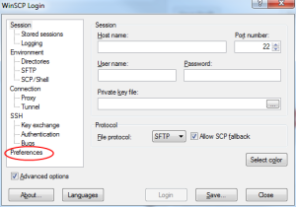](https://en.code-bude.net/wp-content/uploads/sites/2/2014/07/how-to-setup-a-custom-text-editor-in-WinSCP-step-1.png)  [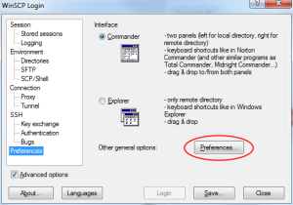](https://en.code-bude.net/wp-content/uploads/sites/2/2014/07/how-to-setup-a-custom-text-editor-in-WinSCP-step-2.png)

1. After you have opened WinSCP you will see the login screen with a tree menu at the left hand. Click on the “Preferences” menu item and then on the “Preferences…” button on the right side.

[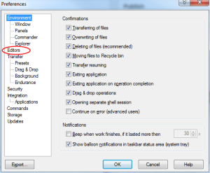](https://en.code-bude.net/wp-content/uploads/sites/2/2014/07/how-to-setup-a-custom-text-editor-in-WinSCP-step-3.png)  [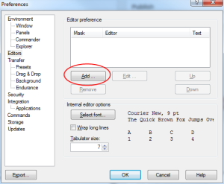](https://en.code-bude.net/wp-content/uploads/sites/2/2014/07/how-to-setup-a-custom-text-editor-in-WinSCP-step-4.png)

1. Now switch to the sub item named “Editors”. At this point you can add, edit and remove editors for different file formats. So if you have configured different editors for different file types WinSCP will open your preferred editor every time you click on the “Edit” button in the WinSCP file manager. To add a new editor simply click on the “Add …” button.

[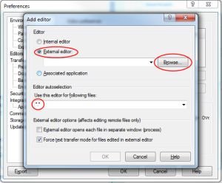](https://en.code-bude.net/wp-content/uploads/sites/2/2014/07/how-to-setup-a-custom-text-editor-in-WinSCP-step-5.png)  [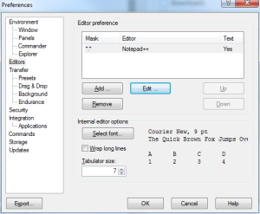](https://en.code-bude.net/wp-content/uploads/sites/2/2014/07/how-to-setup-a-custom-text-editor-in-WinSCP-step-6.png)

1. Choose the option “External editor:”, click on the “Browse…” button and select the path to the Notepad++ executable file. Now you have to define for which file types Notepad++ should be opened. If you want to use Notepad++ for all kind of file types just enter “*.*”. The asterisks are acting as wildcards. That means “*.*” is equally to “any-filename.any-filetype”. If you want to use Notepad++ only for PHP files you should enter this “*.php”.
2. If you’ve done everything alright, Notepad++ should be available out of WinSCP from now on. To proof if everything is ok, open WinSCP and log into one of your servers. Now right click on any (text-) file and click on the “Edit” menu entry and WinSCP should automatically download the file and open it in edit mode in Notepad++. If you’ve done your changes, save the file in Notepad++ and WinSCP will automatically upload it to the server. So that’s how coding makes fun!

# Programming with Python on Pi

import RPi.GPIO as GPIO

# to use Raspberry Pi board pin numbers

GPIO.setmode(GPIO.BCM)

# set up the GPIO channels - one input and one output

GPIO.setup(11, GPIO.IN)

GPIO.setup(12, GPIO.OUT)

# input from pin 11

input_value = GPIO.input(11)

# output to pin 12

GPIO.output(12, GPIO.HIGH)

# the same script as above but using BCM GPIO 00..nn numbers

GPIO.setmode(GPIO.BCM)

GPIO.setup(17, GPIO.IN)

GPIO.setup(18, GPIO.OUT)

input_value = GPIO.input(17)

GPIO.output(18, GPIO.HIGH)

### Simple Input/ Output with RPi and Python

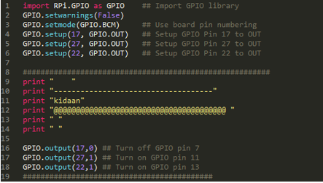

On execution, pin 17 goes low that means led connected to pin 17 goes off else 27 and 22 remains on.

### Simple Input/ Output with delay

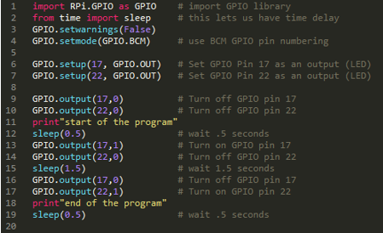

Delay of .5 and 1.5 sec is provided in this program.

### Simple Input/ Output with loop

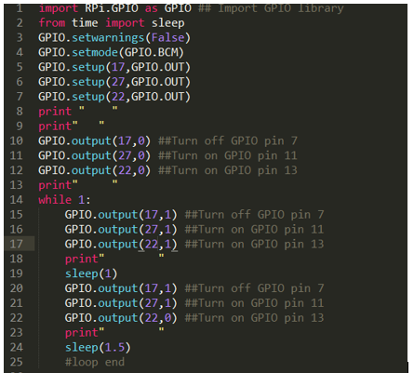

This program will run in forever loop. To terminate this press Ctrl+C.

### Make a Python file Executable

It allows you to run a python program before adding python to filename. To make the program executable run in command prompt:

Chmod 777 filename

To run program enter:

./filename

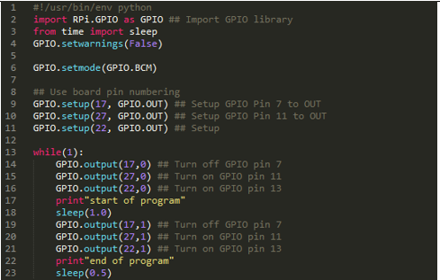

### Input Switch

The switch can be connected to GPIO pins in two ways. The output of the LED will be according to the circuit used.

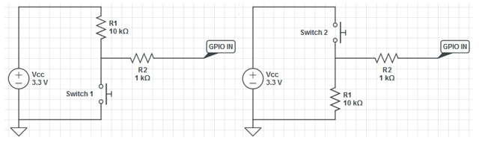

Connect the circuit required. The LED will glow when the switch is pressed and goes off when the switch is not pressed.

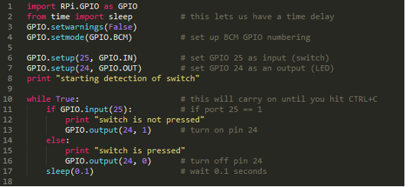

### Pulse Width Modulation

Pulse Width Modulation, or PWM, is a technique for getting analog results with digital means. Digital control is used to create a square wave, a signal switched between on and off. This on-off pattern can simulate voltages in between full on (5 Volts) and off (0 Volts) by changing the portion of the time the signal spends on versus the time that the signal spends off. The duration of "on time" is called the pulse width. To get varying analog values, you change, or modulate, that pulse width. If you repeat this on-off pattern fast enough with an LED for example, the result is as if the signal is a steady voltage between 0 and 5v controlling the brightness of the LED. The green lines represent a regular time period. This duration or period is the inverse of the PWM frequency. In other words, with Arduino's PWM frequency at about 500Hz, the green lines would measure 2 milliseconds each. A call to analogWrite() is on a scale of 0 - 255, such that analogWrite(255) requests a 100% duty cycle (always on), and analogWrite(127) is a 50% duty cycle (on half the time) for example.

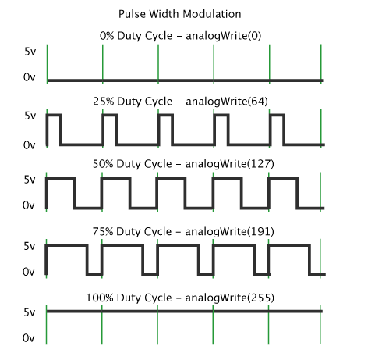

Once you get this example running, grab your arduino and shake it back and forth. What you are doing here is essentially mapping time across the space. To our eyes, the movement blurs each LED blink into a line. As the LED fades in and out, those little lines will grow and shrink in length. Now you are seeing the pulse width.

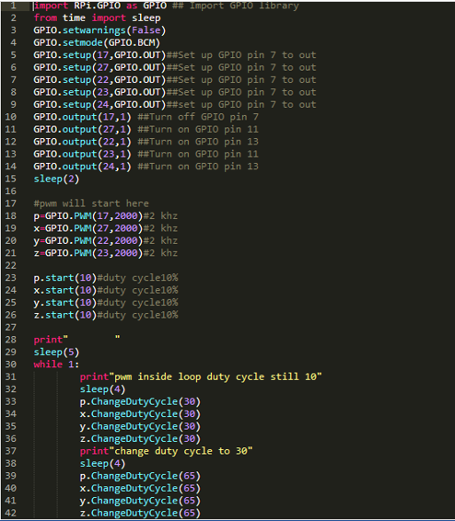 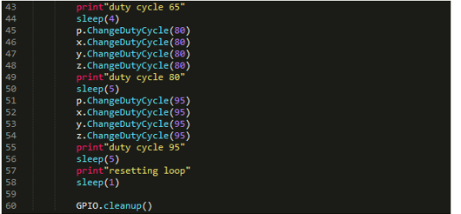

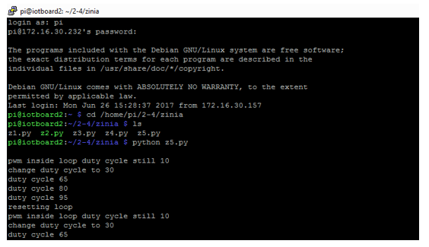

### Program to change Brightness of LED

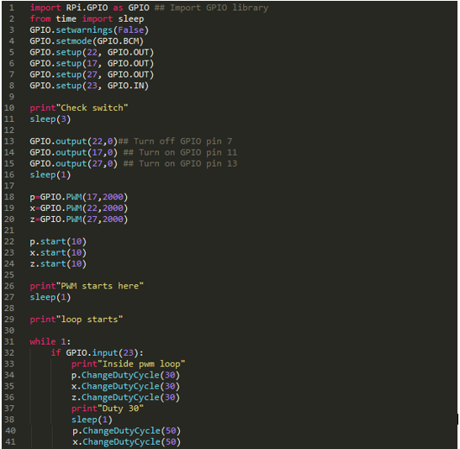

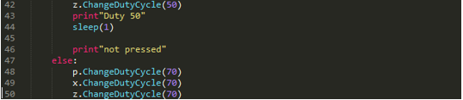 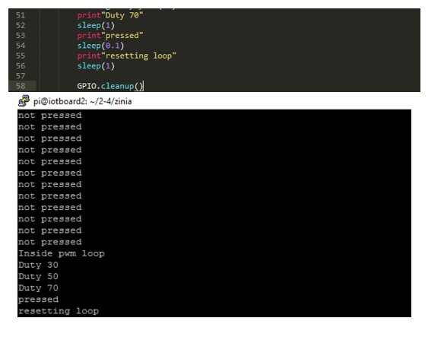

# Sensor

A sensor is a device, module, or subsystem whose purpose is to detect events or changes in its environment and send the information to other electronics, frequently a computer processor. A sensor is always used with other electronics.

Sensors are used in everyday objects such as touch-sensitive elevator buttons (tactile sensor) and lamps which dim or brighten by touching the base, besides innumerable applications of which most people are never aware. With advances in micro-machinery and easy-to-use microcontroller platforms, the uses of sensors have expanded beyond the traditional fields of temperature, pressure or flow measurement,[1] for example into MARG sensors. Moreover, analog sensors such as potentiometers and force-sensing resistors are still widely used. Applications include manufacturing and machinery, airplanes and aerospace, cars, medicine, robotics and many other aspects of our day-to-day life.

We are going to discuss four sensors:

1. LM35
2. LDR
3. DHT11/22
4. DS18B20

Now…

### LM35

LM35 is a precision IC temperature sensor with its output proportional to the temperature (in ‘C). The sensor circuitry is sealed and therefore it is not subjected to oxidation and other processes. With LM35, temperature can be measured more accurately than with a thermistor. It also possess low self-heating and does not cause more than 0.1’C temperature rise in still air.

The operating temperature range is from -55’C to 150’C. The output voltage varies by 10mV in response to every ‘C rise/fall in ambient temperature, i.e., its scale factor is 0.01V/ ‘C.

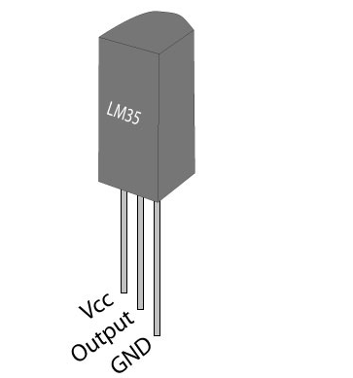

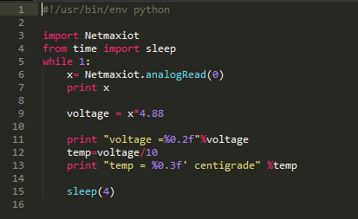

In this program lm35 is connected at analog pin 0 and it gives us voltage and voltage is then converted into temperature by diving voltage by 10.

### LDR

A photoresistor (or light-dependent resistor, LDR, or photo-conductive cell) is a light-controlled variable resistor. The resistance of a photoresistor decreases with increasing incident light intensity; in other words, it exhibits photoconductivity. A photoresistor can be applied in light-sensitive detector circuits, and light-activated and dark-activated switching circuits.

A photoresistor is made of a high resistance semiconductor. In the dark, a photoresistor can have a resistance as high as several mega-ohms (MΩ), while in the light, a photoresistor can have a resistance as low as a few hundred ohms. If incident light on a photoresistor exceeds a certain frequency, photons absorbed by the semiconductor give bound electrons enough energy to jump into the conduction band. The resulting free electrons (and their hole partners) conduct electricity, thereby lowering resistance. The resistance range and sensitivity of a photoresistor can substantially differ among dissimilar devices. Moreover, unique photoresistor may react substantially differently to photons within certain wavelength bands.

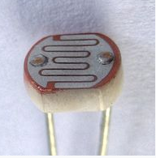

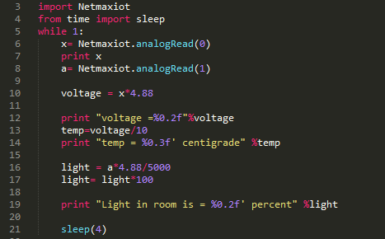

In this program with lm35, ldr is connected at pin 1 and value obtained from this sensor is multiplied by 4.88 because it is 1024 bit sensor. Then divided by 50 to get the value in percentage.

### DHT11

The digital temperature and humidity sensor DHT11 is a composite sensor that contains a calibrated digital signal output of temperature and humidity. The technology of a dedicated digital modules collection and the temperature and humidity sensing technology are applied to ensure that the product has high reliability and excellent long-term stability.

The sensor includes a resistive sense of wet component and an NTC temperature measurement device, and is connected with a high-performance 8-bit microcontroller. The schematic diagram of the Humiture Sensor Module is as shown following:

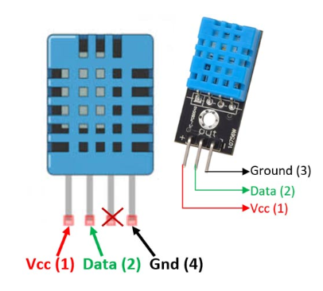

**Specifications**:

Operating Voltage: 3.5V to 5.5V

Operating current: 0.3mA (measuring) 60uA (standby)

Output: Serial data

Temperature Range: 0°C to 50°C

Humidity Range: 20% to 90%

Resolution: Temperature and Humidity both are 16-bit

Accuracy: ±1°C and ±1%

### DHT22

DHT22 output calibrated digital signal. It utilizes exclusive digital-signal-collecting-technique and humidity sensing technology, assuring its reliability and stability. Its sensing elements is connected with 8-bit single-chip computer. Every sensor of this model is temperature compensated and calibrated in accurate calibration chamber and the calibration-coefficient is saved in type of program in OTP memory, when the sensor is detecting, it will cite coefficient from memory. Small size & low consumption & long transmission distance (20m) enable DHT22 to be suited in all kinds of harsh application occasions. Single-row packaged with four pins, making the connection very convenient.

Power supply 3.3-6V DC

Output signal digital signal via single-bus

Sensing element Polymer capacitor

Operating range humidity 0-100%RH;

Temperature -40~80Celsius

Accuracy humidity +-2%RH(Max +-5%RH);

Temperature <+-0.5Celsius

Resolution or sensitivity humidity 0.1%RH;

Temperature 0.1Celsius

Repeatability humidity +-1%RH;

Temperature +-0.2Celsius

Humidity hysteresis +-0.3%RH

Long-term Stability +-0.5%RH/year

Sensing period Average: 2s

Interchangeability fully interchangeable

Dimensions small size 14*18*5.5mm;

Big size 22*28*5mm

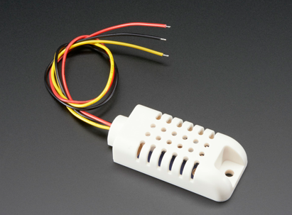

### DS18B20

The DS18B20 digital thermometer provides 9-bit to 12-bit Celsius temperature measurements and has an alarm function with nonvolatile user-programmable upper and lower trigger points. The DS18B20 communicates over a 1-Wire bus that by definition requires only one data line (and ground) for communication with a central microprocessor. It has an operating temperature range of -55°C to +125°C and is accurate to ±0.5°C over the range of -10°C to +85°C. In addition, the DS18B20 can derive power directly from the data line ("parasite power"), eliminating the need for an external power supply. Each DS18B20 has a unique 64-bit serial code, which allows multiple DS18B20s to function on the same 1-Wire bus. Thus, it is simple to use one microprocessor to control many DS18B20s distributed over a large area. Applications that can benefit from this feature include HVAC environmental controls, temperature monitoring systems inside buildings, equipment, or machinery, and process monitoring and control systems.

Accuracy ±2(Max) °C

Function Temp Sensor

Interface Type Serial (1-Wire)

Lead Finish Matte Tin

Mounting Through Hole

MSL Level 1

Operating Supply Voltage 3 to 5.5 V

Operating Temperature -55 to 125 °C

Output Type Digital

Pin Count 3

Product Dimensions 4.95(Max) x 3.94(Max) x 4.95(Max)

Resolution 12 Bit

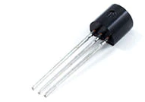

# Pi, DHT11 and Google Interfacing

### Installing Kernel Support with Raspi-Config

To enable this, just enter in command prompt

Sudo raspi-config

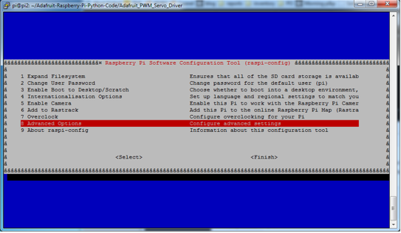

Advanced Options >> select any interface

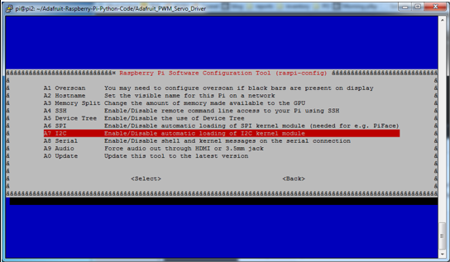

Serial Peripheral Interface (SPI) standard provides a way for digital devices to share data serially.

The Inter-integrated Circuit (I2C) standard was developed to attach peripheral IC’s to microcontroller.

### Installing Software and Libraries

**To start with update your package lists and install a few Python libraries:**

sudo apt-get update

sudo apt-get install build-essential python-dev

**Then clone the Adafruit library from their repository:**

git clone https://github.com/adafruit/Adafruit_Python_DHT.git

cd Adafruit_Python_DHT

then run these commands

sudo apt-get update

sudo apt-get install build-essential python-dev python-openssl

sudo python setup.py install

### Testing the libraries

Navigate to examples present in Adafruit_Python_DHT folder. There examine source code of program like simpletest.py

nano simpletest.py

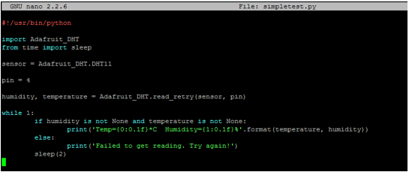

Run this command:

Python simpletest.py

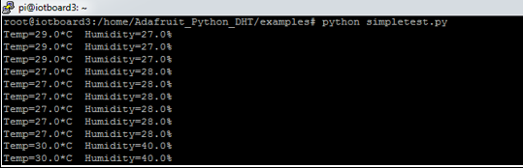

### Google Spreadsheet

With Google spreadsheet program, we can record the reading from the sensor in google spreadsheet. We need ‘json file name’ and the ‘google spreadsheet name’.

**How to create a JSON file:**

JSON stands for JavaScript Object Notation. JSON is a lightweight data-interchange format. It is a minimal, readable format for structuring data and is used primarily to transmit data between a server and web application

1. Search [Google Developers Console](https://console.developers.google.com/project) and create a new project.
2. From  at the top left corner, go to the Dashboard in the API Manager. Click on ‘Enable API’.
3. Select Drive API and then enable it.
4. Go to “Credentials” and choose “Create Credentials > Service Account Key”.

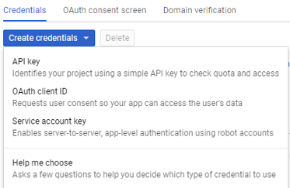

1. Create New Service Account. Select the role ‘Owner’ and the ‘JSON’ key type.

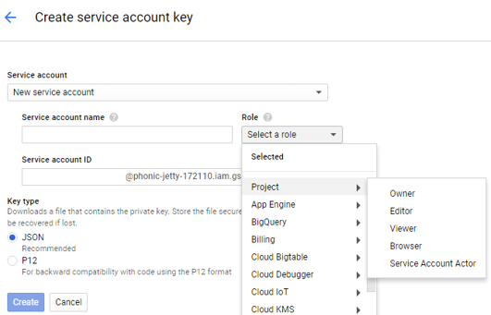

1. Click on Create and you will automatically download a JSON file with this.
2. This is how this file may look like:

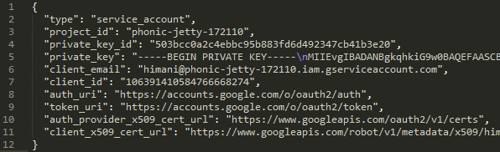**Create and Prepare Spreadsheet:**

1. First up you will need to sign up for Google Docs and create a spreadsheet.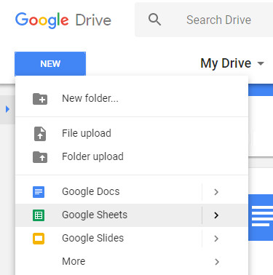
2. Once you've created it, delete all but one line (since we don't want 1000 empty rows)

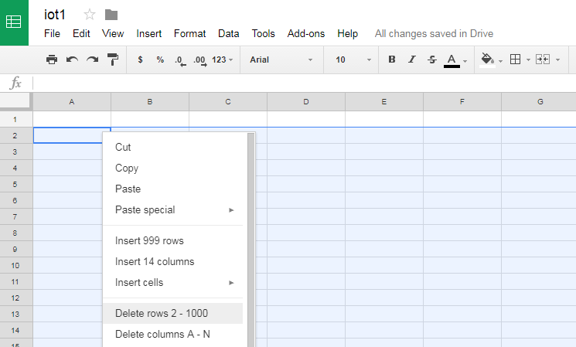

1. First up we will have to install the gspread python library, which will do the heavy lifting of connecting to google docs and updating the spreadsheet. With your board connected and online, run the following:

* sudo apt-get update
* sudo apt-get install python-pip
* apt-get purge python-pyasn1
* pip install pyasn1
* sudo pip install gspread oauth2client

1. Next, in the examples directory again, edit google_spreadsheet.py and adjust the configuration values towards the top of the file.

* nano google_spreadsheet.py

1. Set GDOCS_SPREADSHEET_NAME to the name of your spreadsheet and the GDOCS_OAUTH_JSON to the name of the .json file. Make sure DHT_TYPE is set to the type of sensor you are using (either Adafruit_DHT.DHT11, Adafruit_DHT.DHT22, or Adafruit_DHT.AM2302), and DHT_PIN is set to the GPIO pin number which is connected to your DHT sensor

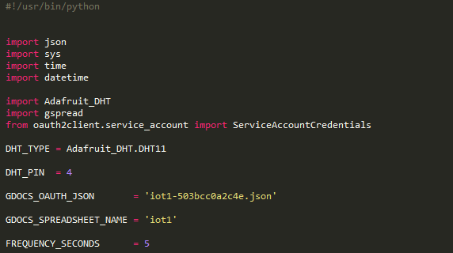

1. Save the file. Now, place the created .json file in the same directory as the google_spreadsheet.py example. If you don't place this file in the same directory then authentication will fail and you will not be able to update your spreadsheet.

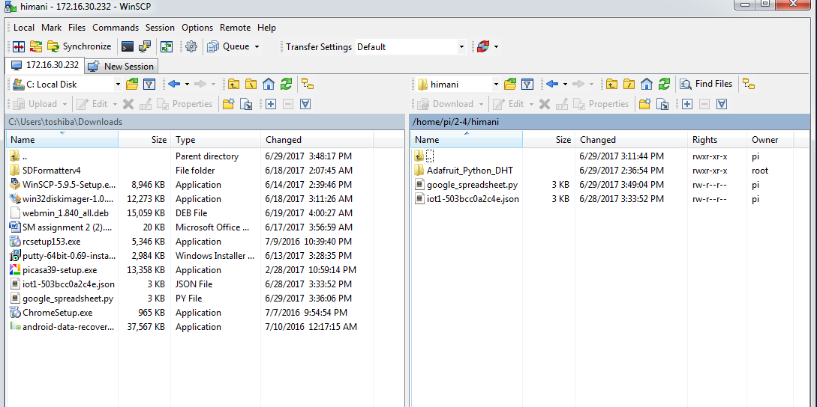

1. One last step that must be completed is to share your Google spreadsheet to the email address associated with the OAuth2 credentials. Open the .json file and search for the "client_email":
2. Take note of that email address value and go to your Google spreadsheet in a web browser. Using the File -> Share... menu item share the spreadsheet with read and write access to the email address found above. Make sure to share your spreadsheet or you will not be able to update it with the script.

Execute the Python script by running -

python google_spreadsheet.py

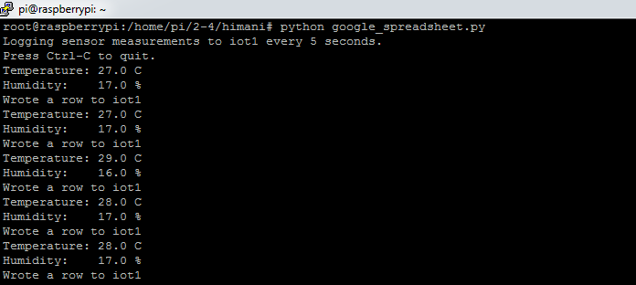

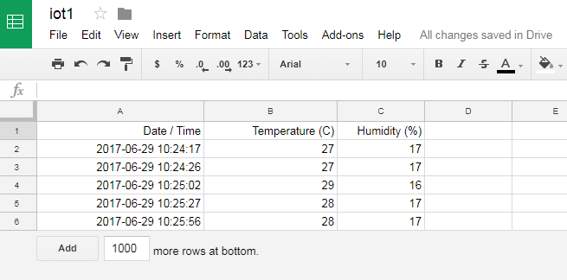

You should see the program run and after about 5 seconds a humidity and temperature measurement is displayed and written to the spreadsheet. The program will continue to run and log a measurement until you force it to quit by pressing Ctrl+C.

The measurement frequency can be adjusted by changing the FREQUENCY_SECONDS configuration in the python code.

Open the spreadsheet on Google's site and you should see measurements added in real time. The same can be seen in the form of graphs as shown below-

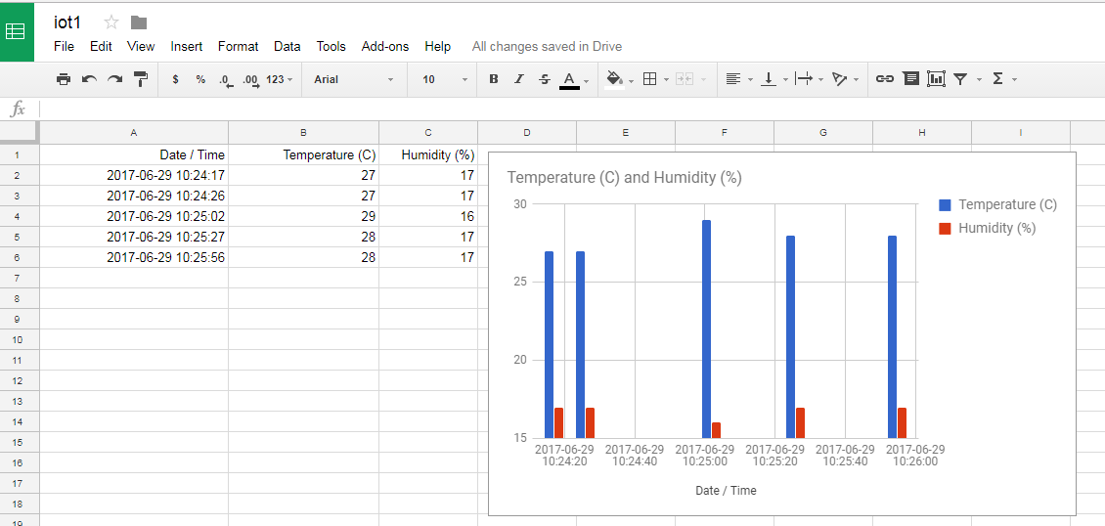

# My Devices

myDevices is an Internet of Things solutions company. We accelerate IoT development and empower enterprises to quickly design, prototype, and commercialize IoT solutions.

To accomplish our mission to simplify the connected world, we created Cayenne – the world’s first drag-and drop IoT project builder. Cayenne enables engineers, makers, network operators and system integrators to quickly and easily develop and deploy IoT solutions across a wide variety of verticals.

Developers can build complete and ready-to-use IoT solutions with little to no coding during the process. Cayenne contains a vast catalog of certified IoT- ready devices and connectivity options, and it allows users the ability to easily add any device into the library utilizing MQTT API. All devices in Cayenne are interoperable and benefit from features including rules engine, asset tracking, remote monitoring and control, and tools to visualize real-time and historical data.

myDevices also provides tools such as SDKs and APIs, in addition to professional services and support, for companies that want to create customized IoT products and apps that take advantage of Cayenne’s revolutionary capabilities. myDevices’ Cayenne is becoming the industry standard for building and delivering finished IoT solutions.

1. Sign Up to Cayenne.
2. Install manually Cayenne on your Raspberry Pi by using Terminal of Raspberry Pi.

wget https://cayenne.mydevices.com/dl/rpi_b8w8pn82i9.sh

sudo bash rpi_b8w8pn82i9.sh -v

Please be patient 10 minute to ultimate the installation process. After this reboot your Raspberry.

1. See Your Device on Cayenne Dashboard

[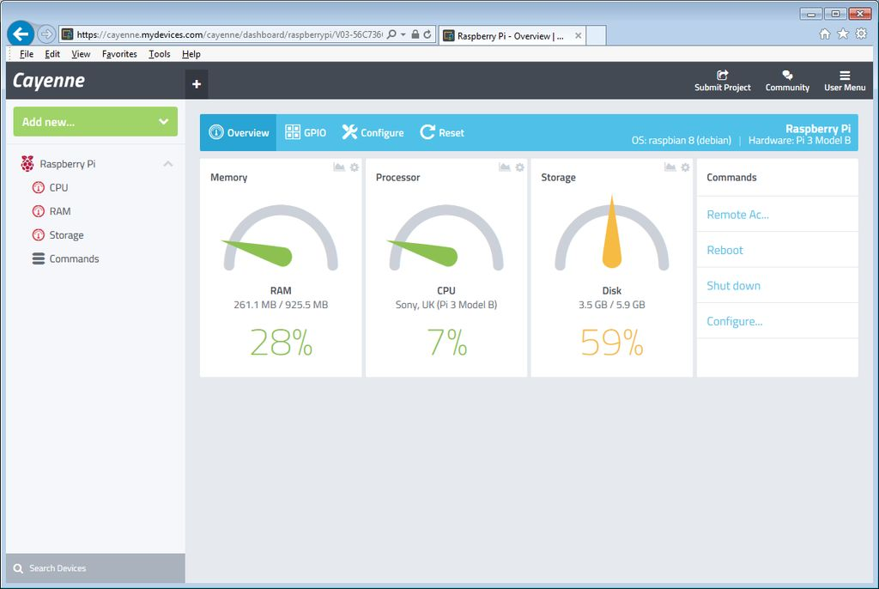](https://cdn.instructables.com/FWQ/NSJE/IQA4UY4X/FWQNSJEIQA4UY4X.LARGE.jpg)

1. Connect a Led to Your Raspberry Pi
2. Create the Buttons on Dashboard

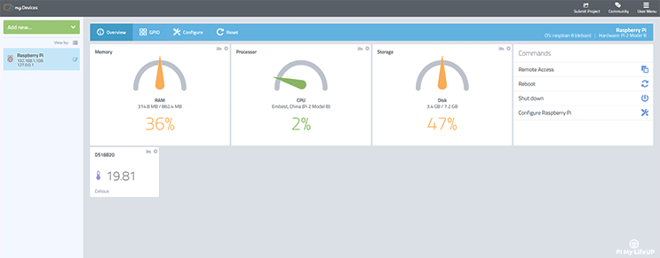

# Particle.io

We believe in the opportunity of the Internet of Things. We believe that, one day, everything will be connected. And when those connections happen, problems will start to disappear. Shelves will be stocked, machines will fix themselves. The world will quietly get better.

In the meantime, we believe that the innovators and entrepreneurs who will create this future need help. This industry is young and its technology is complex. The promise of IoT is only made real when companies ship their products, and today the barriers are too high. Too many great ideas never see the light of day.

So, here we are. We make it easy for our customers to build and deploy IoT products that solve real problems and create real value.

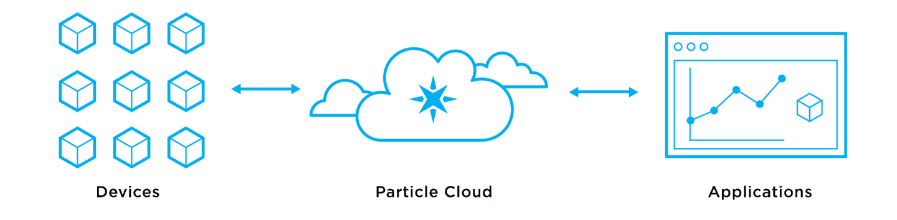

IoT is hard. Particle makes it easy. Particle’s full-stack of Internet of Things(IoT) device platform gives you everything you need to securely and reliably connect your IoT devices to the web.

Particle includes everything you need to deploy an IoT product: a device cloud platform, connectivity hardware, and even SIMs for cellular products.

For using particle.io with the raspberry pi, first make an account in particle.io from [build.particle.io](https://build.particle.io/) .

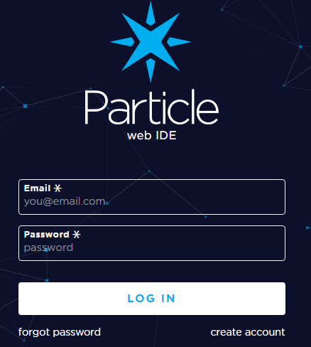

Now go to[docs.particle.io](https://docs.particle.io/)you will see the following options -

* Photon
* Electron
* Core
* Raspberry pi

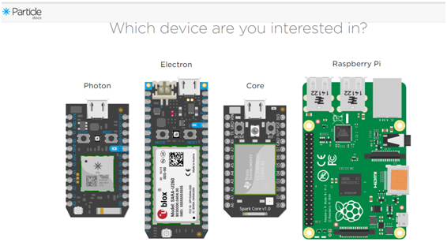

**PHOTON:**

Particle's Internet of Things hardware development kit, the Photon, provides everything you need to build a connected product. Particle combines a powerful ARM Cortex M3 microcontroller with a Broadcom Wifi chip in a tiny thumbnail-sized module called the PØ (P-zero).

To get you started quickly, Particle adds a rock solid 3.3VDC SMPS power supply, RF and user interface components to the PØ on a small single-sided PCB called the Photon.

**Features:**

Particle PØ Wi-Fi module

Broadcom BCM43362 Wi-Fi chip

802.11b/g/n Wi-Fi

STM32F205RGY6 120Mhz ARM Cortex M3

1MB flash, 128KB RAM

On-board RGB status LED (ext. drive provided)

18 Mixed-signal GPIO and advanced peripherals

Open source design

Real-time operating system (FreeRTOS)

Soft AP setup

FCC, CE and IC certified

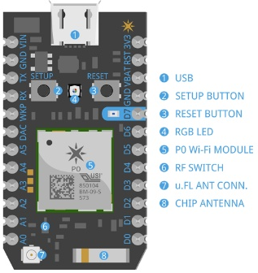

**ELECTRON:**

The Electron is a tiny development kit for creating cellular-connected electronics projects and products. It comes with a SIM card (Nano 4FF) and an affordable data plan for low-bandwidth things.

It also comes with Particle's development tools and cloud platform for managing and interacting with your new connected hardware.

**Features:**

* U-blox SARA-U260/U270 (3G) and G350 (2G) cellular module
* STM32F205RGT6 120MHz ARM Cortex M3 microcontroller
* 1MB flash, 128KB RAM
* BQ24195 power management unit and battery charger
* MAX17043 fuel gauge
* RGB status LED
* 30 mixed-signal GPIO and advanced peripherals
* Open source design
* Real-time operation system (RTOS)
* FCC, CE and IC certified

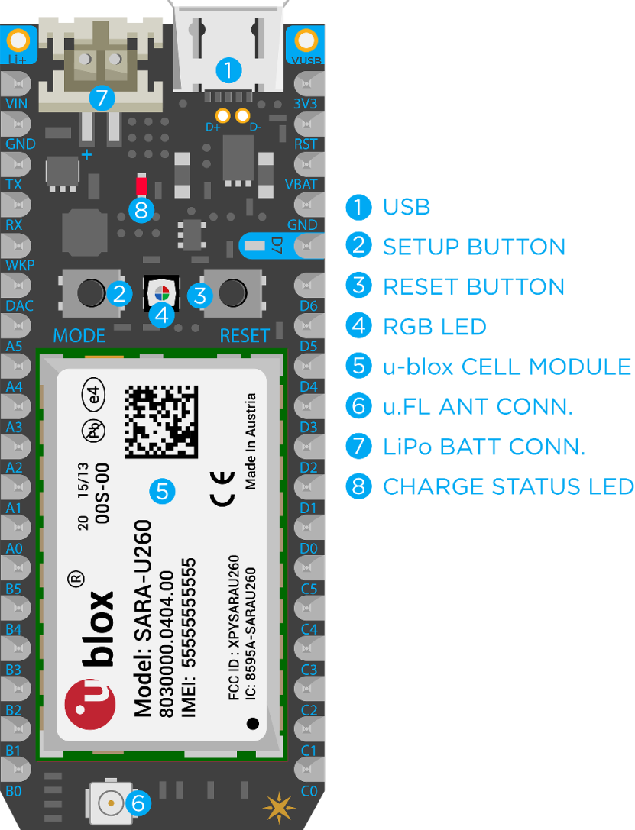

**CORE:**

Spark Core v1.0 uses the STM32F103CB - ARM 32-bit Cortex M3 based - microcontroller for its brain power.

**Features:**

* ARM 32-bit Cortex™-M3 CPU Core
* 72MHz operating frequency, 1.25 DMIPS/MHz (Dhrystone 2.1)
* 128KB of Flash memory
* 20KB of SRAM
* 12 bit ADC
* USB 2.0 full-speed interface
* USART, SPI and I2C interfaces
* JTAG Debug mode

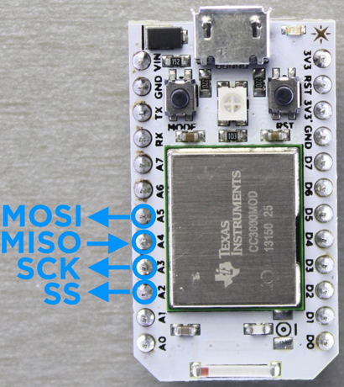

**RASPBERRY PI:**

The Raspberry Pi is an amazing credit-card sized computer with immense possibilities. It is a low-cost single-board Linux computer designed and produced by the Raspberry Pi Foundation. The Particle firmware is being developed on the Raspberry Pi 3.

The Particle Agent software also works on the Pi Zero, original Raspberry Pi and Raspberry Pi 2, but the differences in peripherals and pin mapping means that some firmware and libraries may not compile correctly on older hardware variants. Firmware and library coverage for all versions of Raspberry Pi hardware will improve over time.

The Raspberry Pi is already the world’s most popular low-cost computer, and a powerful development tool for building connected projects. Connecting your Pi to the Particle Cloud gives it a few more key features that will make building IoT projects with your Pi easier than ever.

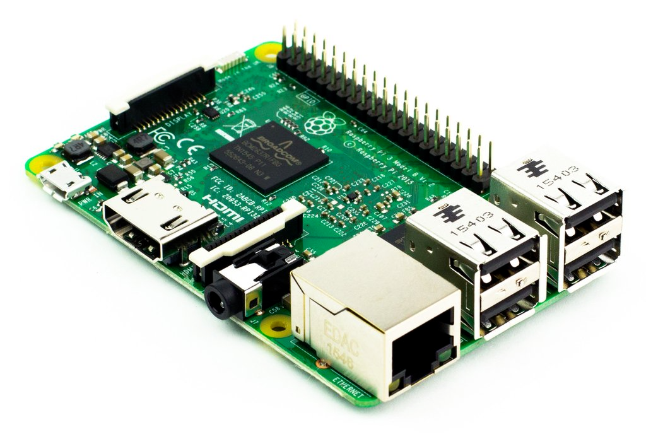

**Particle Pi Beta:**

Please note that the Raspberry Pi integration with the Particle Cloud is currently in beta.

**Quick Install:**

Copy the following command shown on the docs.particle.io page -

bash <( curl -sL https://particle.io/install-pi )

**What You'll Need**

In order to connect your Raspberry Pi to the Particle Cloud you'll need the following things. Note that these are all included in the Particle Pi Starter Kit with Raspberry Pi v3, which is available for purchase in the Particle Store.

* Raspberry Pi (Raspberry Pi v2 and v3 preferred)
* Power supply (5V, 2A+ preferred)
* Micro SD card and SD adapter
* Ethernet cable (for wired connections)

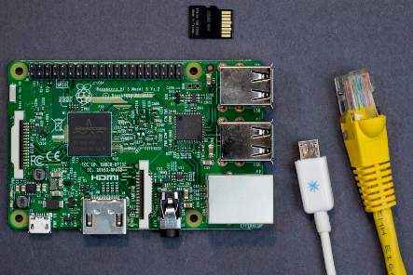

If you do not have access to a wired network cable, you will need to connect your Pi to an active Wi-Fi network, which will require the following:

* Keyboard
* Mouse
* Monitor
* HDMI Cable (to connect Pi to your monitor)

Your raspberry pi should be installed with the latest OS Raspbian. Then connect your Pi to the internet. There are two primary ways to connect your Raspberry Pi to the web--using a wired connection or using a wireless connection (Wi-Fi preferred).

Here we will use method using a wireless connection with LAN cable attached. Therefore, you will have to SSH (secure shell) into your Pi in order to install the Particle software.

**Install the Particle Agent:**

You will not be able to complete this step of the process if you have not already received your beta activation email.

To connect your Raspberry pi to the Particle Cloud, you need to install the Particle Agent. The Particle Agent is a software service that runs in the background on the Raspberry Pi and allows you to write and run firmware (software that interacts with the GPIO pins on the Pi).

Install the agent by pasting the command you copied earlier in a terminal on your Raspberry Pi.

bash <( curl -sL https://particle.io/install-pi )

When the installation is over, the Particle Agent setup will ask you to sign in to your Particle account.

**Control an LED With Particle App:**

Now install the application particle.io in your mobile phone using playstore.

Open Dash-Board and then Open Your "Raspberry Pi" on Device List.

Here, we are using D7 pin on Particle app that belongs to Pi 35 pin or GPIO19 so connect an LED to Pi pin 13 or GPIO19.

Set pins in Particle App. Click on D7 and Select pinMode. Here, we have digitalWrite.

Now Click on D7 button

We are Done! Look at your Pi.

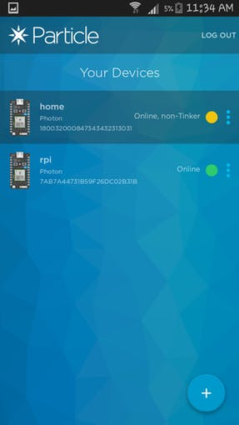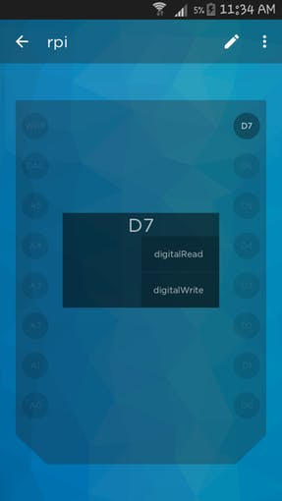

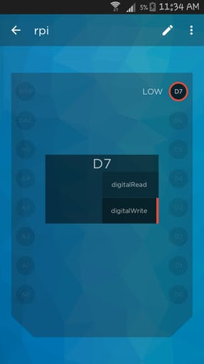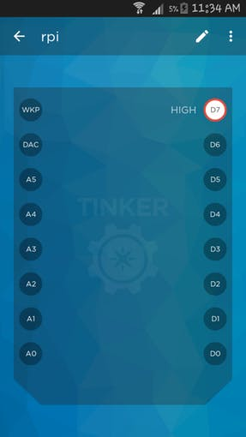

Turn OFF or ON the LED using the D7 button.

That's all; you're now connected to the world's favorite low-cost computer now connects to the world's most popular IoT platform.

# Connect Nodemcu with Adafruit

The ESP8266 based Feather HUZZAH & the HUZZAH ESP8266 breakout are both very popular options for connecting projects to Adafruit IO. In this guide we are going to walk through the setup needed to get your ESP8266 up and running with the Arduino IDE & Adafruit IO. This same basic setup can be used as you progress through our Adafruit IO Basics series of guides.

Before you continue with this guide, you should consider running through the guides for the ESP8266 Feather or the ESP8266 breakout. We will cover all of the basic setup needed for connecting your ESP8266 to Adafruit IO, but the individual guides go into greater detail about each board.

## Pros/Cons of the ESP8266

Here are some quick pros & cons if you are considering using the ESP8266 for your Adafruit IO project.

**Pros**

* Low cost
* Great support via the ESP8266 Arduino community
* Can be programmed using Lua & Python ([MicroPython](https://learn.adafruit.com/building-and-running-micropython-on-the-esp8266)), in addition to Arduino
* Fast Uploads

**Cons**

* Power hungry
* Limited number of GPIO pins
* One analog input pin

## Install the Arduino IDE 1.6.8 or greater

[Download Arduino IDE from Arduino.cc (1.6.8 or greater)](http://www.arduino.cc/en/Main/Software) from Arduino.cc

**Install the ESP8266 Board Package**

Enter http://arduino.esp8266.com/stable/package_esp8266com_index.jsoninto Additional Board Manager URLs field in the Arduino v1.6.4+ preferences.

[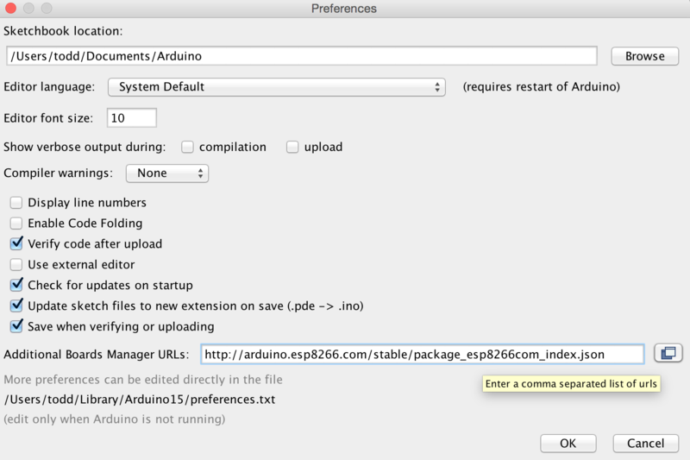](https://learn.adafruit.com/assets/28673)

 Next, use the **Board manager** to install the ESP8266 package.

[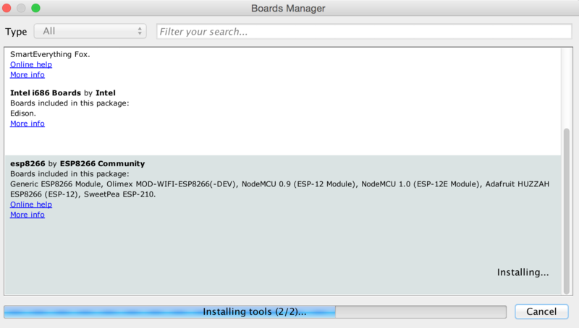](https://learn.adafruit.com/assets/28674)

After the install process, you should see that esp8266 package is marked INSTALLED. Close the Boards Manager window once the install process has completed.

[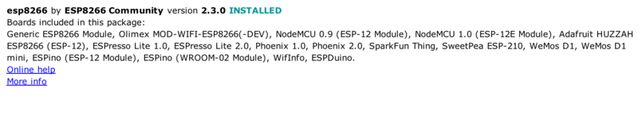](https://learn.adafruit.com/assets/35028)

## Setup ESP8266 Support

When you've restarted, select **Adafruit Feather HUZZAH ESP8266**from the Tools->Board dropdown

[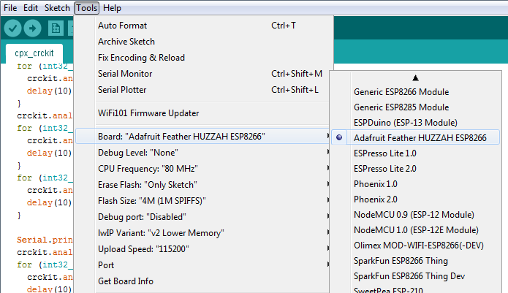](https://learn.adafruit.com/assets/53351)

80 MHz as the CPU frequency

[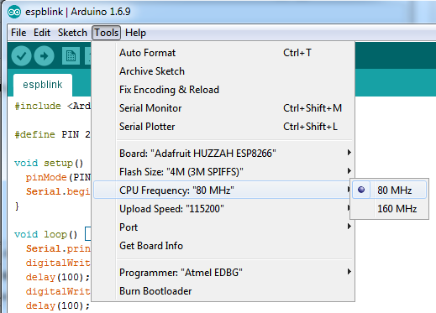](https://learn.adafruit.com/assets/32981)

You can keep the **Flash Size**at "4M (3M SPIFFS)

For **Upload Speed**, select 115200 baud (You can also try faster baud rates, we were able to upload at a blistering 921600 baud but sometimes it fails & you have to retry)

[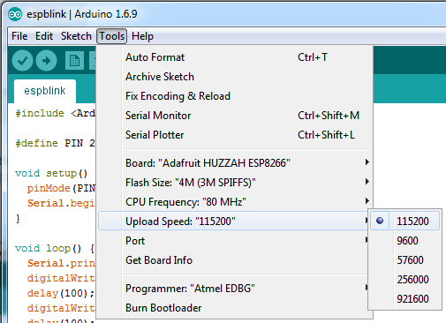](https://learn.adafruit.com/assets/32982)

The matching COM port for your FTDI or USB-Serial cable

[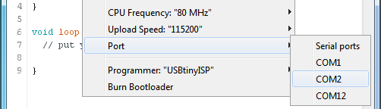](https://learn.adafruit.com/assets/28678)

On a mac, you should look for the "SLAB_USBtoUART" port

[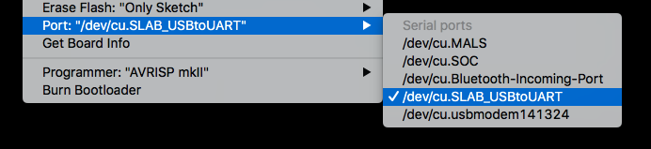](https://learn.adafruit.com/assets/62137)

### Blink Test

We'll begin with the simple blink test

Enter this into the sketch window (and save since you'll have to)

1. void setup() {
2. pinMode(0, OUTPUT);
3. }
5. void loop() {
6. digitalWrite(0, HIGH);
7. delay(500);
8. digitalWrite(0, LOW);
9. delay(500);
10. }

Now you can simply upload! The **Feather HUZZAH** has built in auto-reset that puts it into bootloading mode automagically

[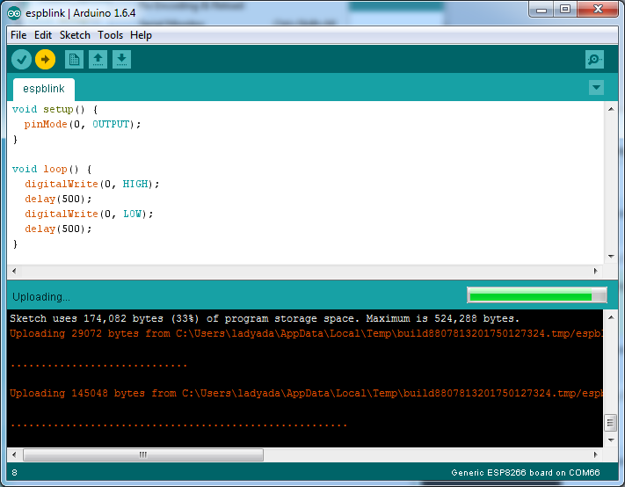](https://learn.adafruit.com/assets/28679)

The sketch will start immediately - you'll see the LED blinking. Hooray!

## Connecting via WiFi

OK once you've got the LED blinking, lets go straight to the fun part, connecting to a webserver. Create a new sketch with this code:

1. /*
2. * Simple HTTP get webclient test
3. */
5. #include <ESP8266WiFi.h>
7. const char* ssid = "yourssid";
8. const char* password = "yourpassword";
10. const char* host = "wifitest.adafruit.com";
12. void setup() {
13. Serial.begin(115200);
14. delay(100);
16. // We start by connecting to a WiFi network
18. Serial.println();
19. Serial.println();
20. Serial.print("Connecting to ");
21. Serial.println(ssid);
23. WiFi.begin(ssid, password);
25. while (WiFi.status() != WL_CONNECTED) {
26. delay(500);
27. Serial.print(".");
28. }
30. Serial.println("");
31. Serial.println("WiFi connected");
32. Serial.println("IP address: ");
33. Serial.println(WiFi.localIP());
34. }
36. int value = 0;
38. void loop() {
39. delay(5000);
40. ++value;
42. Serial.print("connecting to ");
43. Serial.println(host);
45. // Use WiFiClient class to create TCP connections
46. WiFiClient client;
47. const int httpPort = 80;
48. if (!client.connect(host, httpPort)) {
49. Serial.println("connection failed");
50. return;
51. }
53. // We now create a URI for the request
54. String url = "/testwifi/index.html";
55. Serial.print("Requesting URL: ");
56. Serial.println(url);
58. // This will send the request to the server
59. client.print(String("GET ") + url + " HTTP/1.1\r\n" +
60. "Host: " + host + "\r\n" +
61. "Connection: close\r\n\r\n");
62. delay(500);
64. // Read all the lines of the reply from server and print them to Serial
65. while(client.available()){
66. String line = client.readStringUntil('\r');
67. Serial.print(line);
68. }
70. Serial.println();
71. Serial.println("closing connection");
72. }

Dont forget to update

const char* ssid     = "yourssid";  
const char* password = "yourpassword";

to your access point and password, then upload the same way: get into bootload mode, then upload code via IDE

[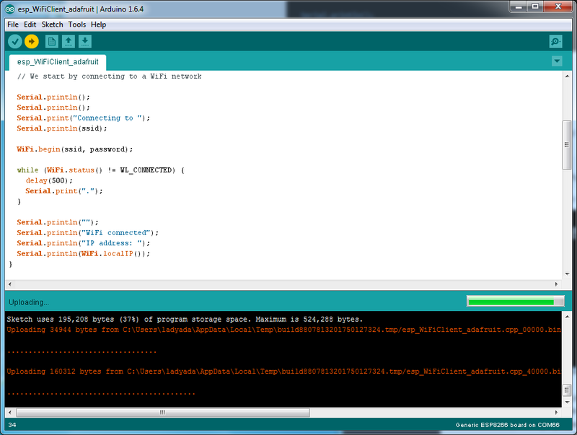](https://learn.adafruit.com/assets/28680)

Open up the IDE serial console at 115200 baud to see the connection and webpage printout!

[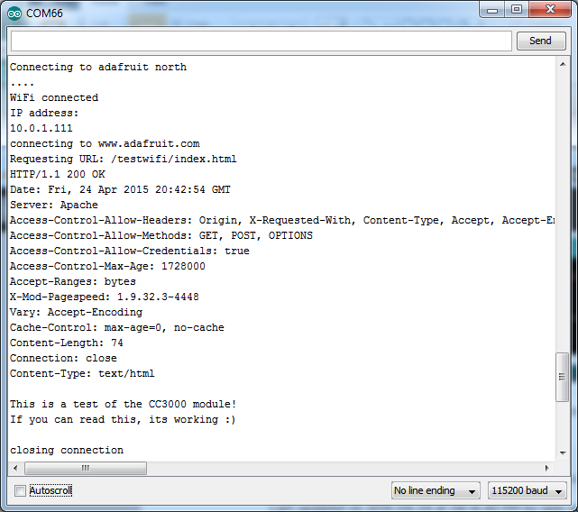](https://learn.adafruit.com/assets/28681)

That's it, pretty easy!

This page was just to get you started and test out your module. For more information, check out the[ESP8266 port github repository](https://github.com/esp8266/Arduino) for much more up-to-date documentation!

## Arduino IO Library

### Install the Required Libraries

Now we will need to install the Adafruit IO, Adafruit MQTT, and ArduinoHttpClient libraries using the Arduino **Library Manager**. Navigate to the **Manage Libraries...** option in the **Sketch -> Include Library** menu.

[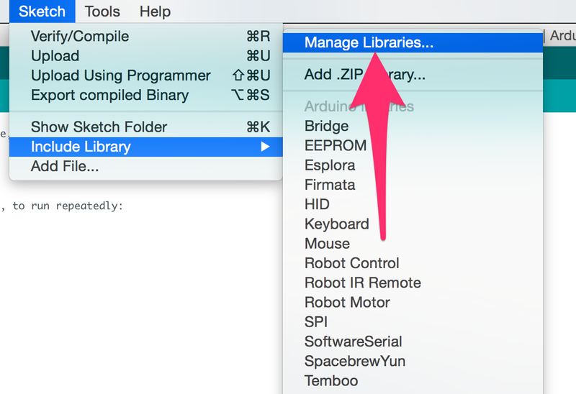](https://learn.adafruit.com/assets/34832)

Enter **Adafruit IO Arduino** into the search box, and click **Install** on the **Adafruit IO Arduino** library option to install version 3.2.0 or higher.

[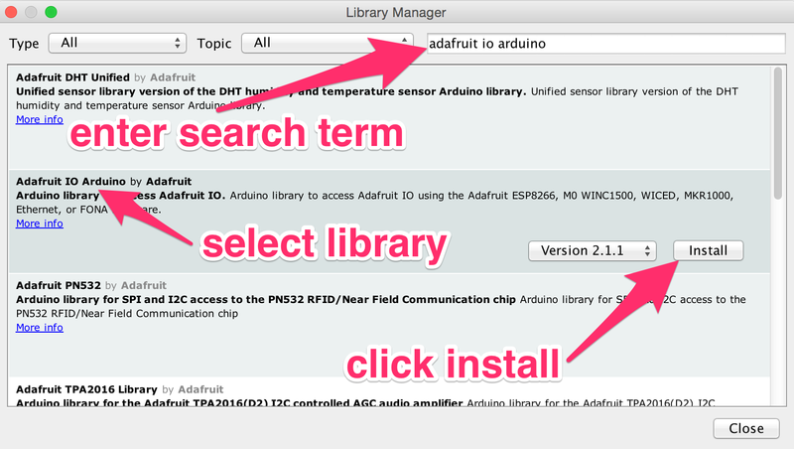](https://learn.adafruit.com/assets/34834)

Enter **Adafruit MQTT** into the search box, and click **Install** on the **Adafruit MQTT** library option to install version 1.0.0 or higher.

[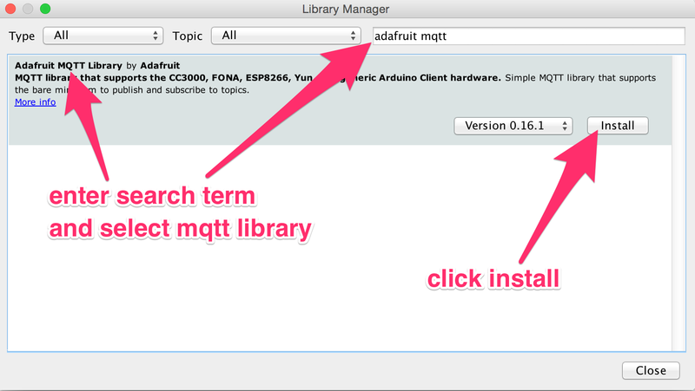](https://learn.adafruit.com/assets/34835)

Enter **ArduinoHttpClient** into the search box, and click **Install** on the **ArduinoHttpClient** library option to install version 0.2.0 or higher.

[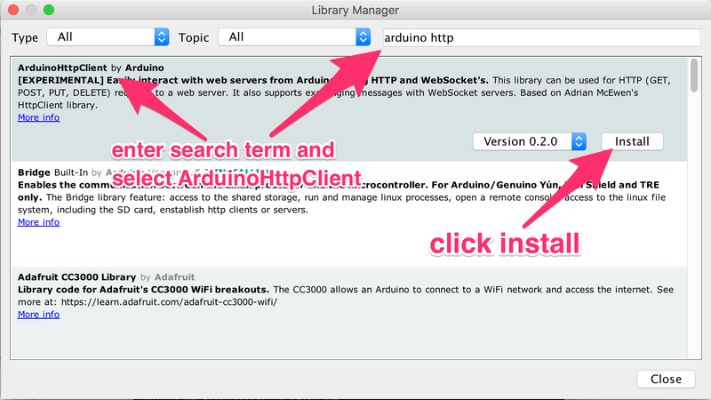](https://learn.adafruit.com/assets/40456)

## Adafruit IO Setup

You are also going to need your Adafruit IO username and secret API key.

[Navigate to your profile](https://io.adafruit.com/)**and click the View AIO Key button** to retrieve them. Write them down in a safe place, you'll need them for the next step.

**Example Sketches**

### Example Sketch Setup

Now that we have installed all of the dependencies, we can try to run one of the Adafruit IO example sketches. Navigate to the **adafruitio_00_publish** sketch by opening the **File -> Examples -> Adafruit IO Arduino** menu.

[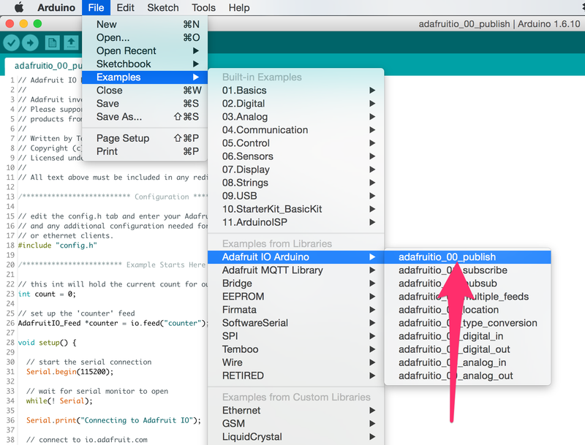](https://learn.adafruit.com/assets/34838)

Click on the **config.h** tab, and replace the placeholders with your Adafruit IO credentials and WiFi connection info.

[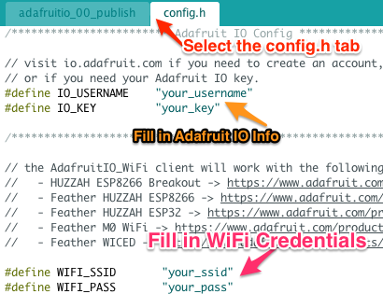](https://learn.adafruit.com/assets/70493)

### Uploading the Sketch

Next we will need to select the **Adafruit HUZZAH ESP8266** from the **Tools -> Board** menu.

[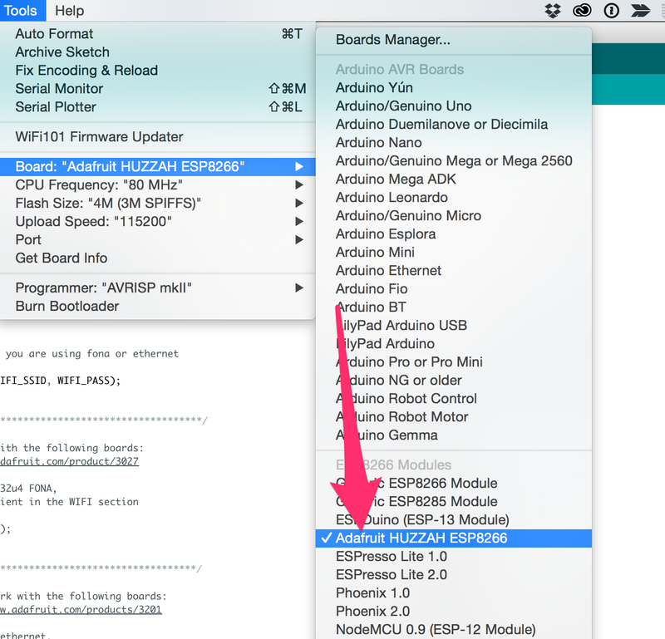](https://learn.adafruit.com/assets/34839)

Then, select the proper COM port on Windows, or USB device on OS X.

[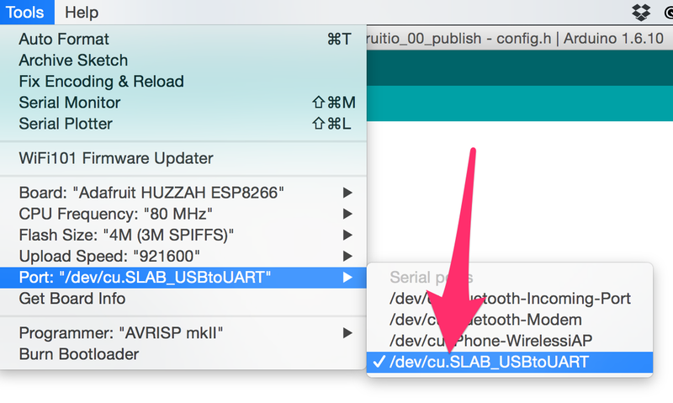](https://learn.adafruit.com/assets/34842)

Use the arrow icon (➡) to upload the example sketch to the ESP8266. It might take a while, but you should see a **Upload complete.** message at the bottom of the window when the process has finished.

[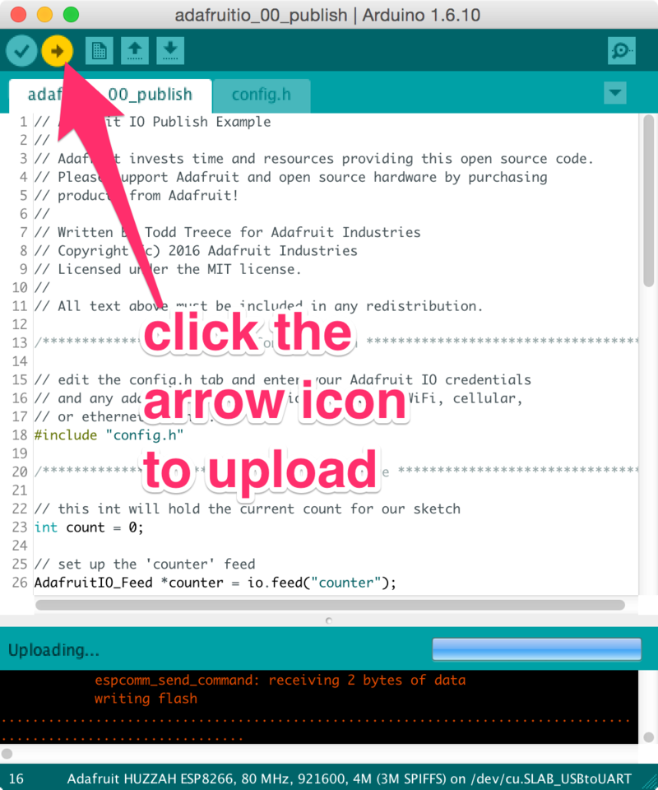](https://learn.adafruit.com/assets/34844)

You can now click the serial monitor icon to view the output of the sketch. If everything goes as expected, you should see counter values being sent to Adafruit IO. If not, check your WiFi and Adafruit IO credentials in **config.h** and try uploading your sketch again using the process above.

[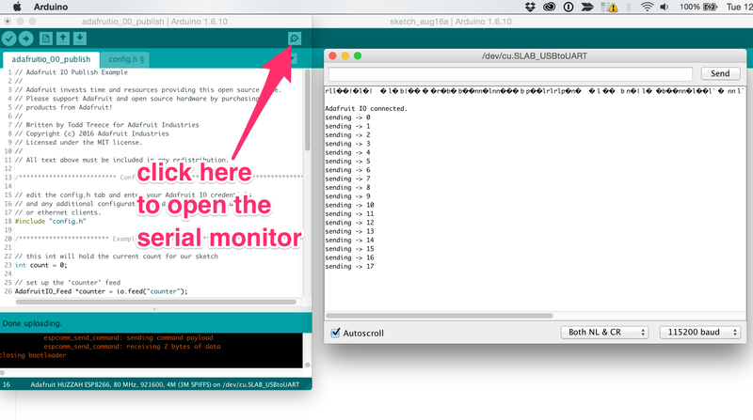](https://learn.adafruit.com/assets/34845)

### Viewing Data on Adafruit IO

Now that your ESP8266 is sending data to Adafruit IO, you can view the data stream on [io.adafruit.com](https://io.adafruit.com/) by adding a stream block to your dashboard. To do this, click on the + icon on the right hand side of the dashboard.

[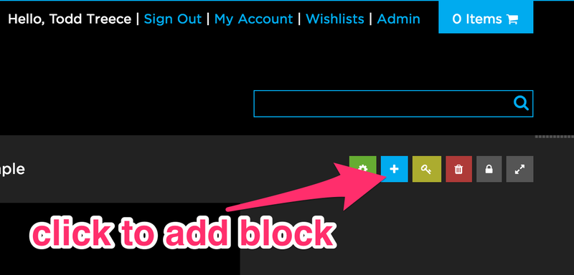](https://learn.adafruit.com/assets/34846)

Add a new **stream block** by selecting it from the modal.

[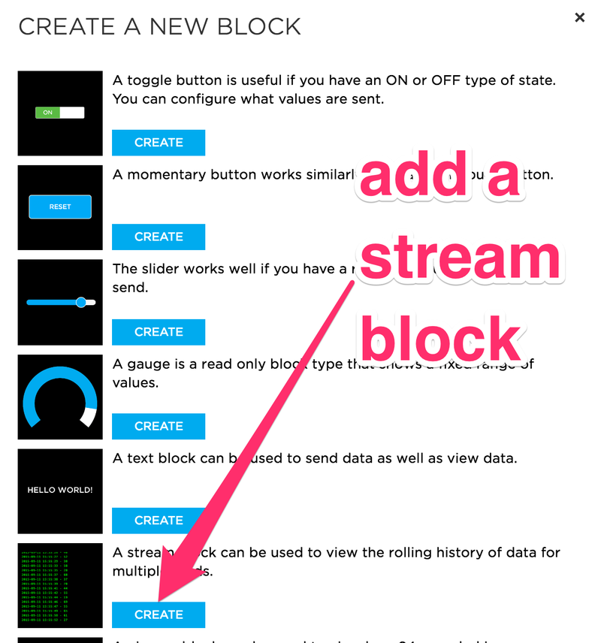](https://learn.adafruit.com/assets/34848)

Next, choose the **counter** feed from the list, and click the **Next Step** button.

[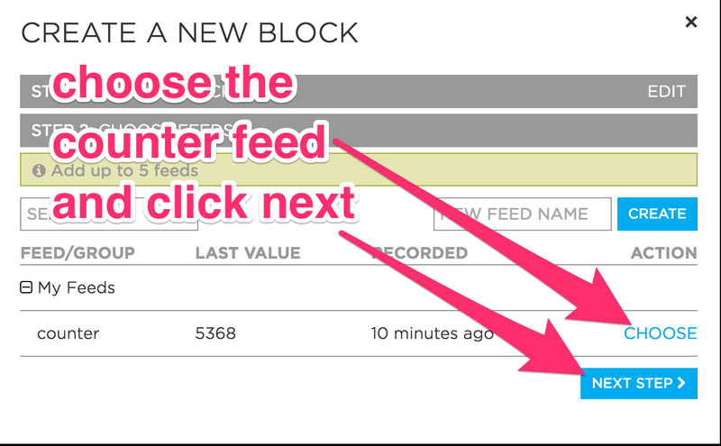](https://learn.adafruit.com/assets/34847)

Modify the stream block options as needed, and click the **create block** button when you are finished.

[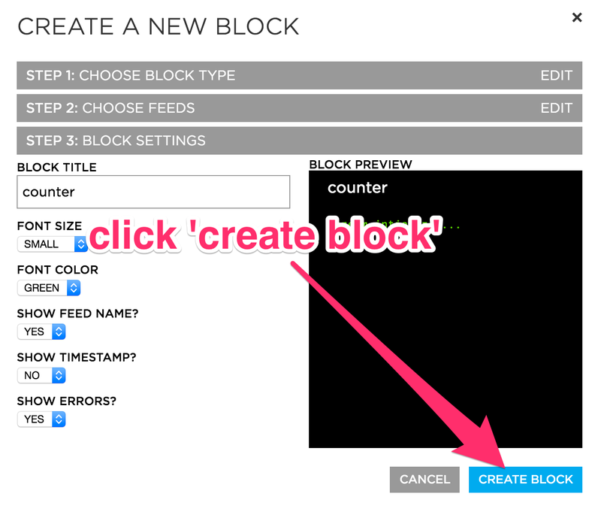](https://learn.adafruit.com/assets/34849)

# Adafruit

Adafruit.io is a cloud service - that just means we run it for you and you don't have to manage it. You can connect to it over the Internet. It's meant primarily for storing and then retrieving data but it can do a lot more than just that!

Steps:

1. Open the adafruit cloud <https://io.adafruit.com>
2. Make an account
3. Go to dashboard and create a new dashboard.
4. Run the program with your API Credentials.

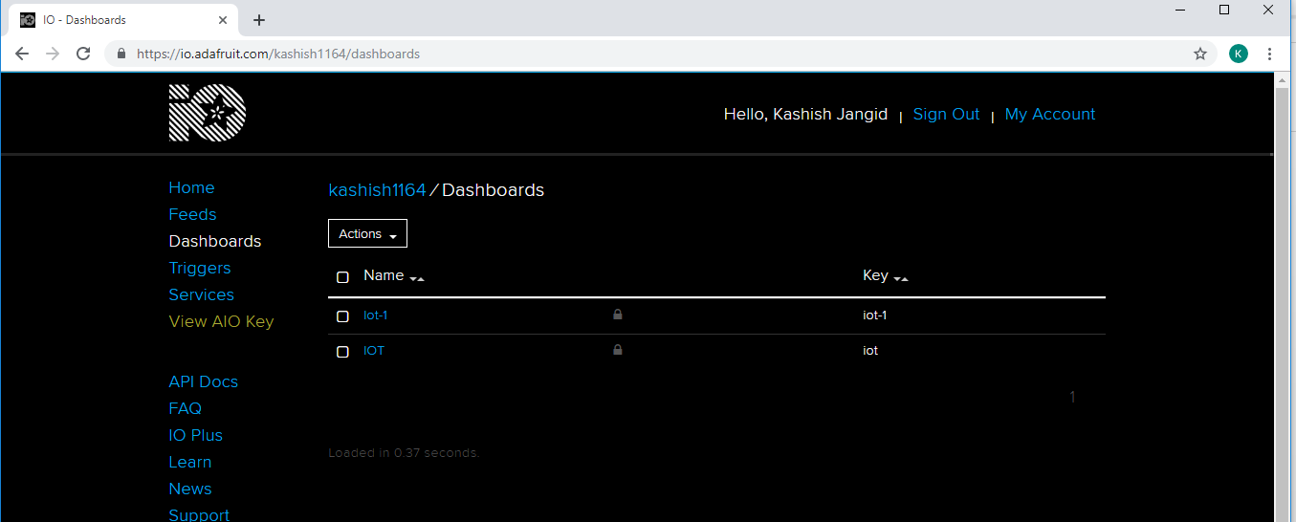

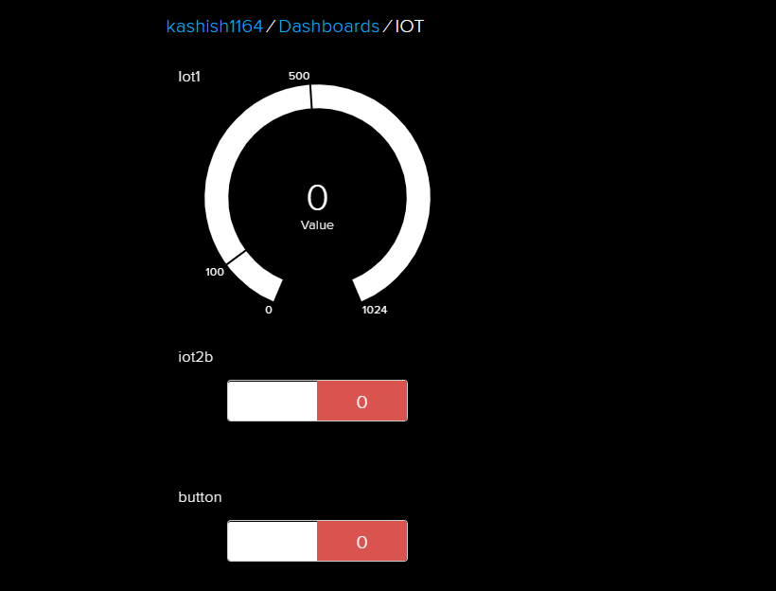

# Ubidots

Steps to use Ubidots cloud:

1. Open <https://apps.ubidots.com>
2. Make an account
3. Go to dashboard and create one.
4. Run your program with your API Credentials

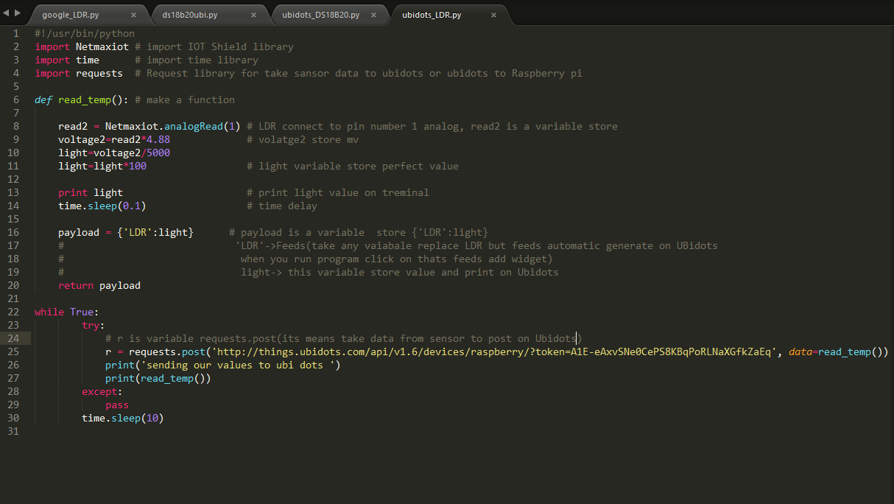

1. Create a widget that you want and add same feed which you have added in the program.

